Editor’s Note: All bracketed items to be edited by NAVFAC FEC PM and ID unless otherwise noted

1.0 SCOPE:

This scope of work describes tasks to be performed by Naval Facilities Engineering Systems Command (NAVFAC) [Pacific] [Southwest] [Northwest] [Hawaii] [Far East] [Marianas] and [the Performing Activity] supporting Collateral Equipment (FQ) for [insert Project number, description and location].

2.0 BACKGROUND:

[Project#, Project Title and DD1391 Block 11 Project Statement and purpose of requested funds.]

3.0 TASKING:
Editor’s Note: Please use the statements below if NAVFAC is the construction agent and FF&E will procured through the contract.
- [Funds shall be sent to the NAVFAC [Pacific] [Southwest] [Northwest] [Hawaii] [Far East] [Marianas]via Purchase Request (PR) to execute the following via [option] [planned modification] to the construction contract. The Contractor shall provide turnkey procurement and installation of the Final Furniture, Fixtures & Equipment (FF&E) package exactly as listed in the attached itemized FF&E Cost Summary (IGE).
- Project Oversight (Project O/S) funding associated with this action will be issued directly to NAVFAC Field Engineering Command (FEC) via TRAM.]

Editor’s Note: Please use this statement if applicable for Host Nation project.
- [Funds shall be sent to DoD execution agent via MIPR to execute the procurement of the FF&E via prime vendor as specified on a firm fixed-price quote.]

Editor’s Note: Please use ONE of the statements below if USACE is the construction agent and FF&E will procured through the contract or via direct procurement from the vendor.
- [Funds shall be sent to USACE via MIPR to execute the following via firm fixed-price option to the construction contract. The Contractor shall provide turnkey procurement and installation of the Final Furniture, Fixtures & Equipment (FF&E) package exactly as listed in the attached itemized FF&E Cost Summary (IGE).]
- [Funds shall be sent to USACE via MIPR to execute the following via direct procurement from the vendor. The Final Furniture, Fixtures & Equipment (FF&E) package will be procured exactly as listed in the attached itemized FF&E Cost Summary (IGE).]

4.0 PLAN OF ACTION AND MILESTONES (POA&M):
(Editor’s Note: PM must confirm schedule dates with CS)
Action Date (Month/Year)
Award FF&E Planned Mod CLIN [insert date]
Procure FF&E [insert date]
Install FF&E [insert date]
CCD or BOD [insert date]

5.0 COST DETAILS: See attached IGE for detailed cost breakdown
(Editor’s Note: Sample provided below. NAVFAC ID to Copy/paste table from Final FF&E Cost Summary (IGE). Totals below must EXACTLY match FF&E Cost Summary. If some fees are combined in same line item on the FF&E Cost Summary, show as combined below, i.e. Design /Project Mgmt Total.)

TOTAL COST SUMMARY:
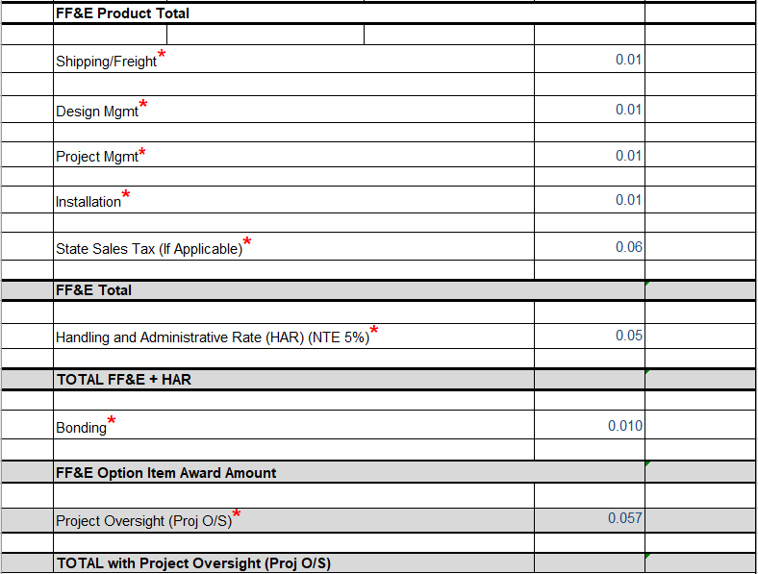

Request funding as follows:

Request funding document be forwarded directly to NAVFAC [Pacific] [Southwest] [Northwest] [Hawaii] [Marianas] [Far East] [Performing Activity] Financial POC(s) for handling. (Editor’s Note: Edited by NAVFAC PAC CEQ Mgr./FQ Technical POC - Must have CFMS Account to receive Funding Doc *** POC at the Performing Activity)

[AAC: N62742

PA Code:

NAVFAC Pacific

Address:

Attn: [POC Name]

Email:

Phone:

Copy to: ]

[AAC: N6247A

PA Code:

NAVFAC Southwest

Address:

Attn: [POC Name]

Email:

Phone:

Copy to: FWF_SW_Core_CI@navy.mil ]

[AAC: N4425A

PA Code:

NAVFAC Northwest

Address:

Attn: POC Name

Email:

Phone:

Copy to: ]

[AAC: N62478

PA Code:

NAVFAC Hawaii

Address:

Attn: POC Name

Email:

Phone:

Copy to: ]

[AAC: N40192

PA Code:

NAVFAC Marianas

Address:

Attn: POC Name

Email:

Phone:

Copy to: ]

[AAC: N40084

PA Code:

NAVFAC Far East

Address:

Attn: POC Name

Email:

Phone:

Copy to: ]

[AAC:

PA Code:

NAVFAC Performing Activity

Address:

Attn: POC Name

Email:

Phone:

Copy to: ]

6.0 POINTS OF CONTACT:

NAVFAC PAC

FQ Technical POC: PAC CEQ Program Manager: Mitch Pascua

Phone: (808) 472-1330

Email: mitchell.g.pascua.civ@us.navy.mil

[Project Manager (PM): Name

Phone:

Email:

Design Mgr. (DM): Name:

Phone:

Email:

Constuction Mgr (CM): Name:
Phone:
Email:

Contract Specialist (CS): Name:
Phone:
Email: ]

CNIC

Technical POC: Maureen Estruch

CNIC N431 Capital Improvements Division-MILCON Branch

MILCON Program Analyst

UMC/Collateral Equipment (FQ) HPD

202-433-4429
maureen.a.estruch.civ@us.navy.mil

Financial POC: Phylia Johnson

Financial Management Analyst

CNIC HQ N851, Execution Team
phylia.d.johnson.civ@us.navy.mil

