Editor’s Note: All items to be edited by FEC PM/ID unless otherwise noted

1.0 SCOPE:

This scope of work describes tasks to be performed by Naval Facilities Engineering Systems Command (NAVFAC) [Atlantic] [Mid-Atlantic] [Southeast] [Washington] [and USACE] [and Performing Activity] supporting Collateral Equipment (FQ) for [P#, Project Title, Location]

2.0 BACKGROUND:

[Project#, Project Title and DD1391 Block 11 Project Statement]

3.0 TASKING:
Editor’s Note: Please use the statements below if NAVFAC is the construction agent and FF&E will procured through the contract.
- [Funds shall be sent to the NAVFAC [Atlantic] [Mid-Atlantic] [Southeast] [Washington] via Purchase Request (PR) to execute the following via [option] [planned modification] to the construction contract. The Contractor shall provide turnkey procurement and installation of the Final Furniture, Fixtures & Equipment (FF&E) package exactly as listed in the attached itemized FF&E Cost Summary (IGE).
- Project Oversight (Project O/S) funding associated with this action will be issued directly to NAVFAC Field Engineering Command (FEC) via TRAM.]

Editor’s Note: Please use ONE of the statements below if USACE is the construction agent and FF&E will procured through the contract or via direct procurement from the vendor.
- [Funds shall be sent to USACE via MIPR to execute the following via firm fixed-price option to the construction contract. The Contractor shall provide turnkey procurement and installation of the Final Furniture, Fixtures & Equipment (FF&E) package exactly as listed in the attached itemized FF&E Cost Summary (IGE).]
- [Funds shall be sent to USACE via MIPR to execute the following via direct procurement from the vendor. The Final Furniture, Fixtures & Equipment (FF&E) package will be procured exactly as listed in the attached itemized FF&E Cost Summary (IGE).]

4.0 PLAN OF ACTION AND MILESTONES (POA&M):
(Editor’s Note: Please confirm schedule dates with CS)
Action Date (Month/Year)
FF&E Funding Required
Award FF&E Option/Planned Mod CLIN
Procure FF&E
Install FF&E
BOD

Mission Impact Statement:
(Editor’s Note: Provide Mission Impact Statement identifying consequences if FF&E funding is not provided by FF&E Funding Required date.)

5.0 COST DETAILS: See attached IGE for detailed cost breakdown
(Editor’s Note: Sample provided below. Copy/paste table from Final FF&E Cost Summary (IGE). Totals below must EXACTLY match FF&E Cost Summary. If some fees are combined in same line item on the FF&E Cost Summary, show as combined below, i.e. Design /Project Mgmt Total.)

TOTAL COST SUMMARY:

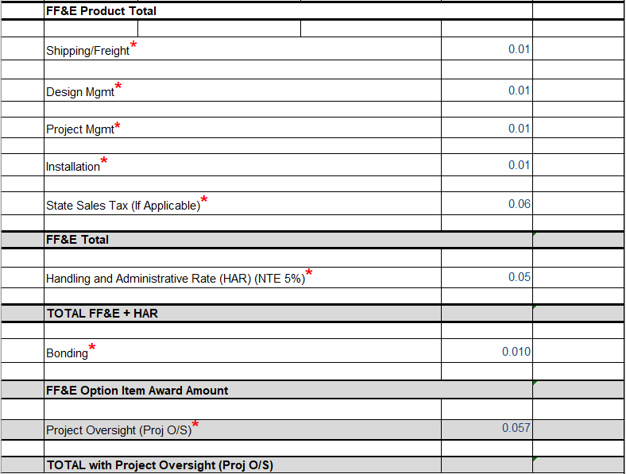

Request funding as follows:

Request funding to be forwarded directly to the [NAVFAC Atlantic] [NAVFAC Mid-Atlantic] [NAVFAC Southeast] [NAVFAC Washington] [USACE] Financial POC(s) for handling. (Editor’s Note: Populated by LANT CEQ Mgr. - Must have CFMS Account to receive Funding Doc *** POC at the Performing Activity)

6.0 POINTS OF CONTACT:

NAVFAC & USACE

Technical POC: Margaret (Peggy) Noland

757-322-4392

margaret.m.noland.civ@us.navy.mil

Financial/Accepting POC: (Editor’s Note: Populated by LANT CEQ Mgr. - Must have CFMS Account to receive Funding Doc *** POC at the Performing Activity)

[(LANT, EURAFCENT)

AAC : N62470

NAVFAC Atlantic

6506 Hampton Blvd.

Norfolk, VA

Attn: Chris Huggins

757-322-4117

christine.a.huggins2.civ@us.navy.mil

AAC : N62470

PA Code: LD

NAVFAC Atlantic

6506 Hampton Blvd.

Norfolk, VA

Attn: Dwayanie Holmes

757-322-4729
dwayanie.p.holmes.civ@us.navy.mil

Copy To: fwf_navfac_lant_core_ci@navy.mil]

[AAC : N40085

PA Code: 85

NAVFAC Mid-Atlantic

9742 Maryland Ave Building A-81 F

Norfolk, VA

Attn: Ruther Grant

757-341-1347
ruther.m.grant.civ@us.navy.mil

Copy To: FWF_ML_Core_CI@navy.mil ]

[AAC : N69450
NAVFAC Southeast
PA Code: TT
PO Box 30
Jacksonville, FL 32212-0030
Attn: Timothy J. Covey
904-542-6234
timothy.j.covey.civ@us.navy.mil]
Copy To: FWF_SE_Core_CI@navy.mil

[AAC : N40080
NAVFAC Washington
PA Code: FF
1314 Harwood St SE
Washington, DC
Attn: LoAmmi Goodwin
202-685-3020
loammi.l.goodwin.civ@us.navy.mil]
Copy To: NAVFAC_Wash_NWCF_Funding_Document_Requests@navy.mil

[(USACE Winchester - Middle East District (Bahrain) – AF )

PA Code 963372

USACE, Middle East District

CETAM-CD-MP

P.O. Box 2250

Winchester, VA 22604-1450

Attn: Claire Wilson - Program Analyst

540-665-5398

claire.m.wilson@usace.army.mil]

[(USACE Europe District (Poland, Romania) – W2 )

PA Code: W912GB

USACE, Europe District

CE-NAU

CMR410

P.O. Box 20

APO, AE 09049

Attn: Tom Downing - Program Analyst

011-49-611-9744-2533

DSN 314-570-2533

Thomas.m.downing@usace.army.mil ]

[(USACE)

Juliette Ephriam / Jennifer Gamble-Cruz

CESAM-RM-AB-MIPRS@usace.army.mil

Juliette.C.Ephriam@usace.army.mil (251) 441-5546 Jennifer.Y.Gamble-Cruz@usace.army.mil (251) 694-3883

Agency Location Code: 00008735

Government Org Code: 36628C002

MOBILE'S DODACC: W31XNJ MILITARY DODACC DUNS/BPN/TPN: DODW31XNJ CIVIL DODACC

DUNS/BPN: DOD964145

Martha Resto, Program Analyst

(251) 690-2751

Martha.Z.Resto@usace.army.mil

Mailing Address:

US Army Corps of Engineers, Mobile District

Attn: CESAM-PM-AF

P.O. Box 2288

Mobile, AL 36628-0001]

Project Mgr. (PM): [Name

Telephone

Email]

Interior Designer (ID): [Name

Telephone

Email]

Construction Mgr. (CM): [Name

Telephone

Email]

Contract Specialist (CS): [Name

Telephone

Email]

Program Analyst (PA): [Name

Telephone

Email]

CNIC

Technical POC: Maureen Estruch

MILCON Program Analyst

UMC/Collateral Equipment (FQ) HPD

CNIC N431 Capital Improvements Division - MILCON Branch

202- 433-4429

maureen.a.estruch.civ@us.navy.mil

Financial POC: Phylia Johnson

Financial Management Analyst

CNIC HQ N851, Execution Team
phylia.d.johnson.civ@us.navy.mil

