**Do Not Print This Section – Template Instructions**

1. Update project information below. This should update many of the project specific information and headers/footers in the template. For the “Type of Cost Estimate” field below:
   1. Civil Works – Recommend documenting year and type of cost estimate per ER 1110-2-1302 Paragraph 14: Alternative Formulation, Tentatively Selected Plan (TSP), Feasibility, Baseline Cost Estimate (BCE), Current Working Estimate (CWE), Independent Government Estimate (IGE), etc.
   2. MILCON – Recommend documenting year and type of cost estimate per UFC 3-740-05 Chapter 2-4: Programming/Budgetary Estimate, Current Working Estimate (CWE), Independent Government Estimate (IGE), or Independent Cost Estimate (ICE).

|  |  |
| --- | --- |
| Description | Information |
| Agency: | **U.S. Army Corps of Engineers** |
| Prepared for: | **Walla Walla District** |
| Prepared by: | **USACE Cost MCX** |
| Project Name: | **Project Name** |
| Location: | **City, XX** |
| Type of Cost Estimate: | **20XX Type of Cost Estimate** |
| Date of CSRA Report: | **Month YYYY** |
| Risk Register Meeting Date: | **MM/DD/YYYY** |
| Confidence Level of CSRA: | **80%** |

1. Update the project photo on the cover page.
2. In Section 1, Purpose, delete the CSRA guidance that does not apply to the project (Civil Works = ER 1110-2-1302 whereas MILCON = UFC 3-740-05). This information is highlighted yellow.
3. Update Section 2, Project Scope. Recommend listing the current status of the project, project scope, and any other pertinent information specific to the project. This information is highlighted yellow.
4. Update Section 3, Key Assumptions. Recommend listing anything that could drastically affect the analysis such as: concerns, inclusions, exclusions, geotechnical analysis, H&H analysis, surveying, acquisition strategy, funding, etc. If contingencies were provided by others, recommend documenting that information as well. This information is highlighted yellow.
5. In Section 4, Cost & Schedule Risk Analysis Process, delete the CSRA guidance that does not apply to the project (Civil Works = Civil Works Processes for Cost & Schedule Risk Analysis whereas MILCON = UFC 3-740-05). This information is highlighted yellow.
6. Update the cost & schedule values, contingencies, price levels, etc. in Section 7.1; information is highlighted yellow.
7. Update top cost risk item bullets in Section 7.2.2; information is highlighted yellow.
8. Update top schedule risk item bullets in Section 7.3.2; information is highlighted yellow.
9. Update all figures and tables throughout the document as they relate to your project.
10. For Appendixes A & B, recommend providing a short 1-2 page summary of the base estimate and high-level 1-2 page summary of the base schedule which supports this CSRA.
11. Update Table of Contents & page number references. ***Tip to update entire document 🡪 Press ‘Ctrl + A’, Press ‘F9”, Select “Update entire table” (multiple times for TOC, figures, & tables).***
12. Print this report to PDF. From the MS Excel CSRA file, print the risk dashboards (Appendix C-1), contingency summary (Appendix C-2), sensitivity charts (Appendix C-3), risk register (Appendix C-4), CSRA assumptions (Appendix C-5), risk register attendance (Appendix C-6), and risk details (Appendix C-7) to PDF and append the information to the report PDF document.

**Project Name**

**City, XX**

**CSRA for 20XX Type of Cost Estimate**

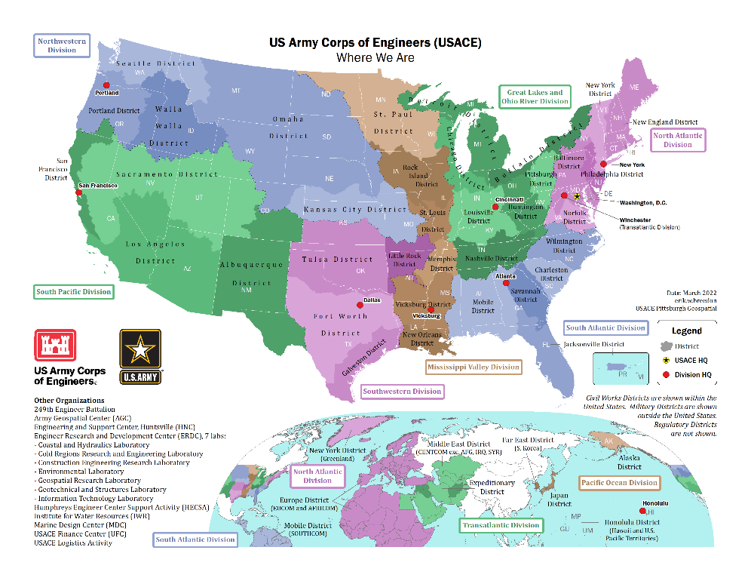

**Prepared by:**

***USACE Cost MCX***

***Month YYYY***

**Table of Contents**

1. Purpose 1

2. Project Scope 1

3. Key Assumptions 1

4. Cost & Schedule Risk Analysis Process 1

5. Base Estimate 1

6. Base Schedule 2

7. Cost & Schedule Risk Analysis 2

7.1. Summary of Results 2

7.2. Cost Risk Analysis 3

7.3. Schedule Risk Analysis 5

8. Recommendations, Risk Management, & Updates 7

8.1. Recommendations 7

8.2. Risk Management 7

8.3. Risk Analysis Updates 7

**Figures**

Figure 1. Cost Contingency Levels 3

Figure 2. Top Cost Risks 4

Figure 3. Schedule Contingency Levels 5

Figure 4. Top Schedule Risks 6

**Tables**

Table 1. Summary of CSRA Results 3

Table 2. Cost Confidence Levels 3

Table 3. Schedule Confidence Levels 5

**Appendixes**

Appendix A: Base Estimate

Appendix B: Base Schedule

Appendix C: Cost & Schedule Risk Analysis Details

# Purpose

The U.S. Army Corps of Engineers (USACE), Walla Walla District, presents this Cost and Schedule Risk Analysis (CSRA) report regarding the risk findings and recommended contingencies for the Project Name 20XX Type of Cost Estimate. A *Monte-Carlo* based risk analysis was conducted by the Project Development Team (PDT) on remaining costs in compliance with Engineer Regulation (ER) 1110-2-1302, CIVIL WORKS COST ENGINEERING (for Civil Works projects) ***OR*** UFC 3-740-05, Construction Cost Estimating (for MILCON projects). The purpose of this risk analysis study is to present the cost and schedule risks considered and respective project contingencies at a recommended 80% confidence level of successful execution to project completion.

# Project Scope

Recommend providing a brief summary of the project location, background, major scope items, assumed contract acquisition strategy, etc.

# Key Assumptions

Recommend documenting key assumptions regarding the analysis. Some common examples are:

* Funding. Are there funding limitations or potential delays in acquiring funding?
* Sponsor. Is there a sponsor involved? Do their capabilities impact funding on when work can be performed if activities need to be completed by the sponsor?
* Contract Acquisition Strategy. How many contracts will there be to execute the project?
* Construction vs. Total Project. Is the CSRA evaluating just construction or the total project which could include real estate, design, engineering during construction, construction management, etc.? This sometimes varies based on what was requested.
* Contingency Sources. Sometimes contingencies are provided to the cost engineer and not varied in the CSRA. Example, real estate contingencies on many USACE projects are provided by the Real Estate Community of Practice (CoP). Still recommend evaluating the schedule risks for these items since it could increase risk to other project components.
* Geotechnical. Have investigative drilling or studies been conducted which support the design? If this data is not currently available, it could drastically impact scope, cost, and schedule if it varies much from the current assumptions.
* Hydraulics & Hydrology. Has hydraulic modeling or studies been conducted which support the design? If this data is not currently available, it could drastically impact scope, cost, and schedule if it varies much from the current assumptions.
* Surveying/Mapping. Does recent survey or mapping data support quantity development?
* Construction Schedule. Has a construction schedule been developed that factors in weather days, work calendars, holidays, winter shutdown periods, work window restrictions, constraints, lead-times, non-construction activities, etc. which could impact the implementation schedule?

# Cost & Schedule Risk Analysis Process

Refer to the “Civil Works Processes for Cost & Schedule Risk Analysis” ***OR*** Chapter 14 of the UFC 3-740-05, Construction Cost Estimating, for guidance and details on the CSRA process.

# Base Estimate

See Appendix A for a summary of the base cost estimate from which this CSRA was conducted.

# Base Schedule

See Appendix B for a summary of the base schedule from which this CSRA was conducted.

# Cost & Schedule Risk Analysis

The CSRA results are provided in the following sections. In addition to contingency calculation results, the top cost and schedule risks were identified, and sensitivity analyses are presented to provide decision makers with:

* An understanding of variability and the key contributors,
* Contingency information for scheduling, budgeting, and project control purposes, and
* Provide tools to support decision making and risk management as projects progress through planning and implementation.

Additional information and details can be found in various Appendix C subsections which are described below.

* **Appendix C-1: Risk Dashboards.** Summary of the top cost & schedule risk items, confidence levels, and suggested risk reduction measures.
* **Appendix C-2: Contingency Summary.** Summary of the various contingency values for cost & schedule by confidence level.
* **Appendix C-3: Sensitivity Charts.** Summary of the major cost & schedule risk items along with a graphical representation of their potential range of impacts at the 50%, 80%, and 90% confidence levels.
* **Appendix C-4: Risk Register.** Summary of the risk register documenting risk type, risk details, likelihood, impact ratings, responsibility, suggested risk reduction measures, etc.
* **Appendix C-5: CSRA Assumptions.** Summary of the risk matrix, likelihood of occurrence definition, impact or consequence definitions for cost / schedule, and cost / schedule impact ranges as they relate to this project.
* **Appendix C-6: Risk Register Attendance.** Summary of the participants of the risk register meeting which was conducted on MM/DD/YYYY.
* **Appendix C-7: Risk Details (if applicable).** Some projects and their risk items could require more complex calculations to determine their risk impact ranges. This is not a mandatory requirement, but risk detail sheets are sometimes developed to help document these assumptions and calculations. These risk detail sheets are typically not included by default but can be available upon request.

## Summary of Results

The base estimate is approximately $297.9M escalated to the mid-point of construction excluding contingency. Based on the results of the analysis, the **CSRA recommends a contingency value of $116.2M, or approximately 39% of base estimate at the** 80% **confidence level of successful execution. The base schedule is approximately 65 months excluding contingency. Based on the results of the analysis,** the **CSRA recommends a contingency value of almost 14.9 months, or approximately 23% of base schedule at the** 80% **confidence level of successful execution.** See Table 1 below for a more detailed summary and Appendix C for additional details regarding risk-based contingency development.

Table 1. Summary of CSRA Results





## Cost Risk Analysis

### Cost Confidence Levels

The result of risk or uncertainty analysis is quantification of the cumulative impact of all analyzed risks or uncertainties as compared to probability of occurrence. These results, as applied to the analysis herein, depict the overall base estimate with contingency at intervals of confidence (probability). Table 2 provides the cost contingencies calculated for the various confidence levels with the 80% confidence level highlighted. Figure 1 presents this information graphically. Contingencies are rounded up to the nearest whole percentage.

Table 2. Cost Confidence Levels

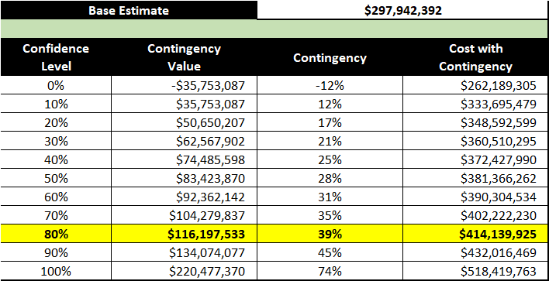

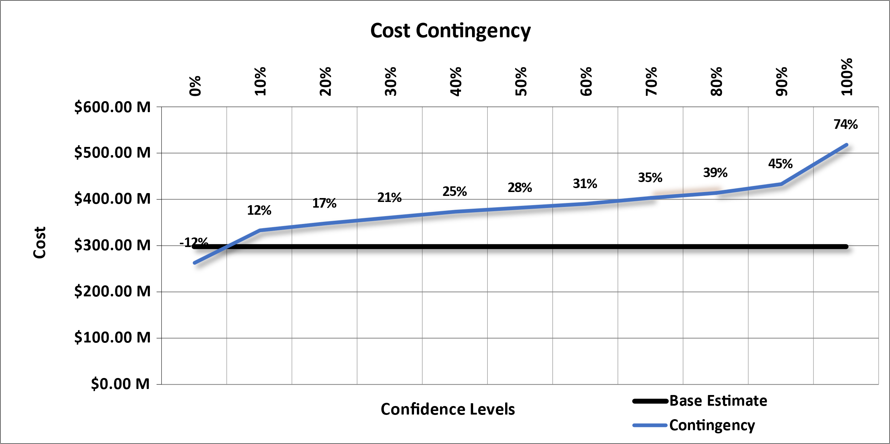

Figure . Cost Contingency Levels

### Top Cost Risks

The risks/opportunities considered as key or primary cost drivers are ranked in order of potential impact (positive or negative) in Figure 2 at various confidence levels (50%, 80%, and 90%). Opportunities are shown with a negative sign to reflect the potential to decrease cost; risks are shown with a positive sign to reflect the potential to increase cost. These key cost drivers can be used to support development of a risk management plan that will facilitate control of risk factors and their potential impacts throughout the project lifecycle. Together with the risk register, these results can also be used to support development of strategies to eliminate, mitigate, accept, or transfer key risks. See Appendix C for additional details for these risks and further information regarding CSRA development.

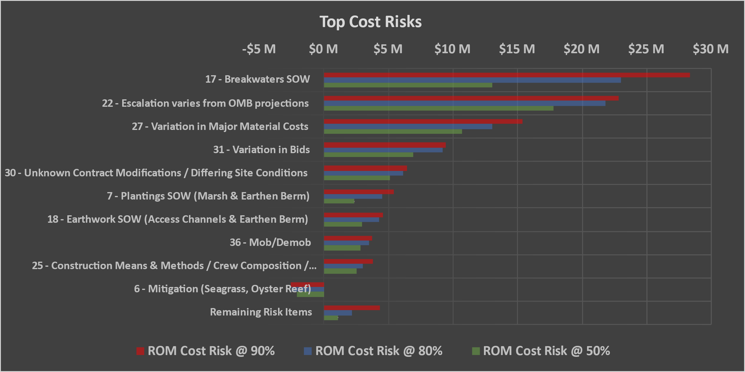

Figure 2. Top Cost Risks

* **Risk 17: Breakwaters.** There is limited survey data and the design height could change resulting in quantity changes. If area is too shallow, additional dredging may be needed. Stone is intended to be placed on the river bottom. The alignment could also shift closer/further from the channel to best match the survey data.
* **Risk 22: Escalation varies from OMB projections.** OMB inflation projections could vary from actual inflation.
* **Risk 27: Variation in Major Material Costs.** Several quotes were received for the major materials to be used for the project. The average of these quotes was used to establish the baseline which could vary significantly if the min or max were used.
* **Risk 31: Variation in Bids.** Even with a perfect IGE, bids can be awarded up to 25% of the IGE without profit based on the number of bids, bid competition, market conditions, etc.
* **Risk 30: Unknown Contract Modifications / Differing Site Conditions.** Contract mods exist on every project and can vary based on the feature of work.
* **Risk 7: Plantings SOW (Marsh & Earthen Berm).** Quantity and timeframe of plantings could impact cost/schedule.
* **Risk 18: Earthwork SOW (Access Channels & Earthen Berm).** There is limited survey data, quantity uncertainty for final dimensions, unknowns associated with quality of borrow material, wildlife windows and/or species protection, and material concerns with sides of channel and potential sediment trap/widening, have not swung out that wide with dredge before. The number of mobs/demobs could also vary.
* **Risk 36: Mob/Demob.** Mob/demob costs vary significantly between various contractors.
* **Risk 25: Construction Means & Methods / Crew Composition / Production Rates.** Estimated production rates could vary as well as the assumed number of crews working concurrently. Major activities are rip rap placement & dredging.
* **Risk 6: Mitigation (Seagrass, Oyster Reef).** The amount of mitigation could vary related to oyster reefs and seagrass.

## Schedule Risk Analysis

### Schedule Confidence Levels

The result of risk or uncertainty analysis is quantification of the cumulative impact of all analyzed risks or uncertainties as compared to probability of occurrence. These results, as applied to the analysis herein, depict the overall schedule duration at intervals of confidence (probability). Table 3 provides the schedule duration contingencies calculated for the various confidence levels with the 80% confidence level highlighted. Figure 3 presents this information graphically. Contingencies are rounded up to the nearest whole percentage.

Table 3. Schedule Confidence Levels

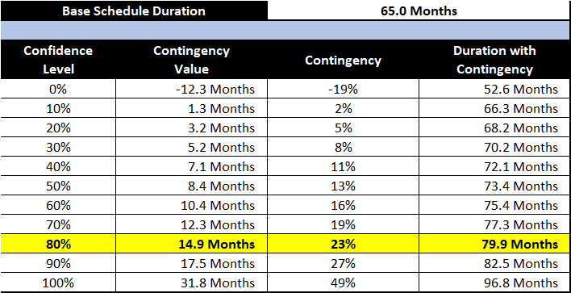

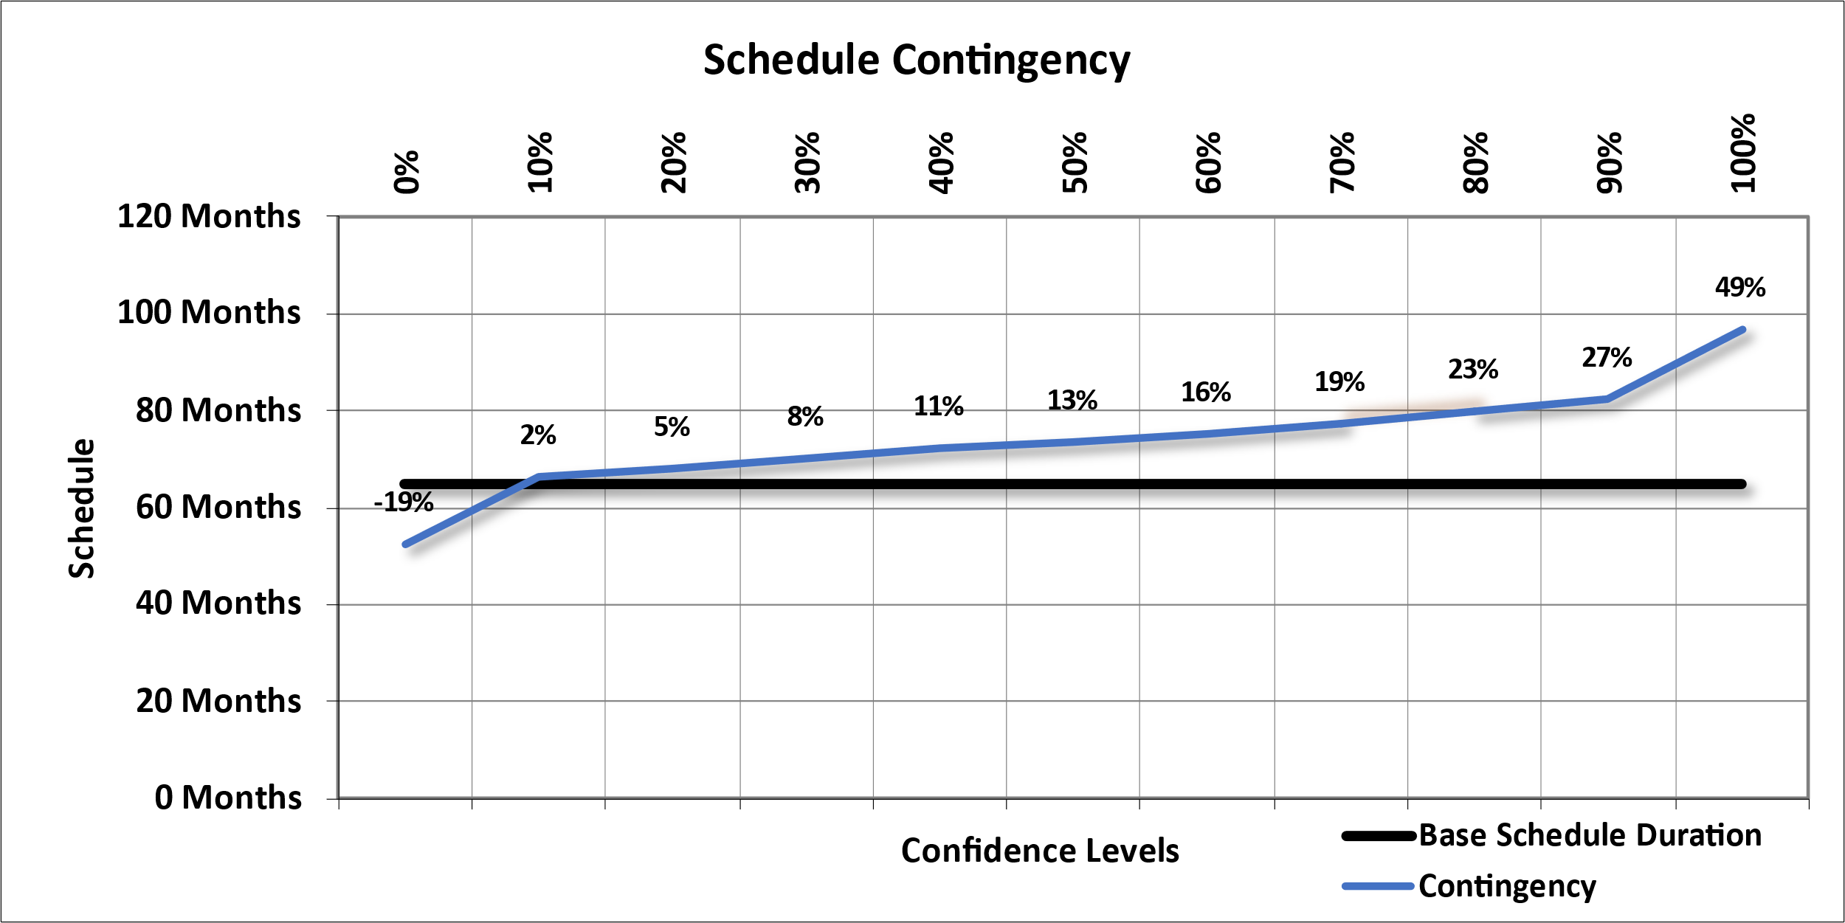

Figure . Schedule Contingency Levels

These contingencies were also used to calculate the projected residual fixed cost impact of project delays that are included in the Table 2 presentation of total cost contingency. The schedule contingencies were calculated by applying the high-level schedule risks identified in the risk register for each option to the durations of critical path and near critical path tasks.

The schedule was not resource loaded and contained open-ended tasks and non-zero lags (gaps in the logic between tasks) that limit the overall utility of the schedule risk analysis. These issues should be considered as limitations in the utility of the schedule contingency data presented. Schedule contingency impacts presented in this analysis are based solely on projected residual fixed costs.

### Top Schedule Risks

The risks/opportunities considered as key or primary schedule drivers are ranked in order of potential impact (positive or negative) in Figure 4 at various confidence levels (50%, 80%, and 90%). Opportunities are shown with a negative sign to reflect the potential to decrease schedule duration; risks are shown with a positive sign to reflect the potential to increase schedule duration. These key schedule drivers can be used to support development of a risk management plan that will facilitate control of risk factors and their potential impacts throughout the project lifecycle. Together with the risk register, sensitivity analysis results can also be used to support development of strategies to eliminate, mitigate, accept, or transfer key risks. See Appendix C for additional details for these risks and further information regarding CSRA development.

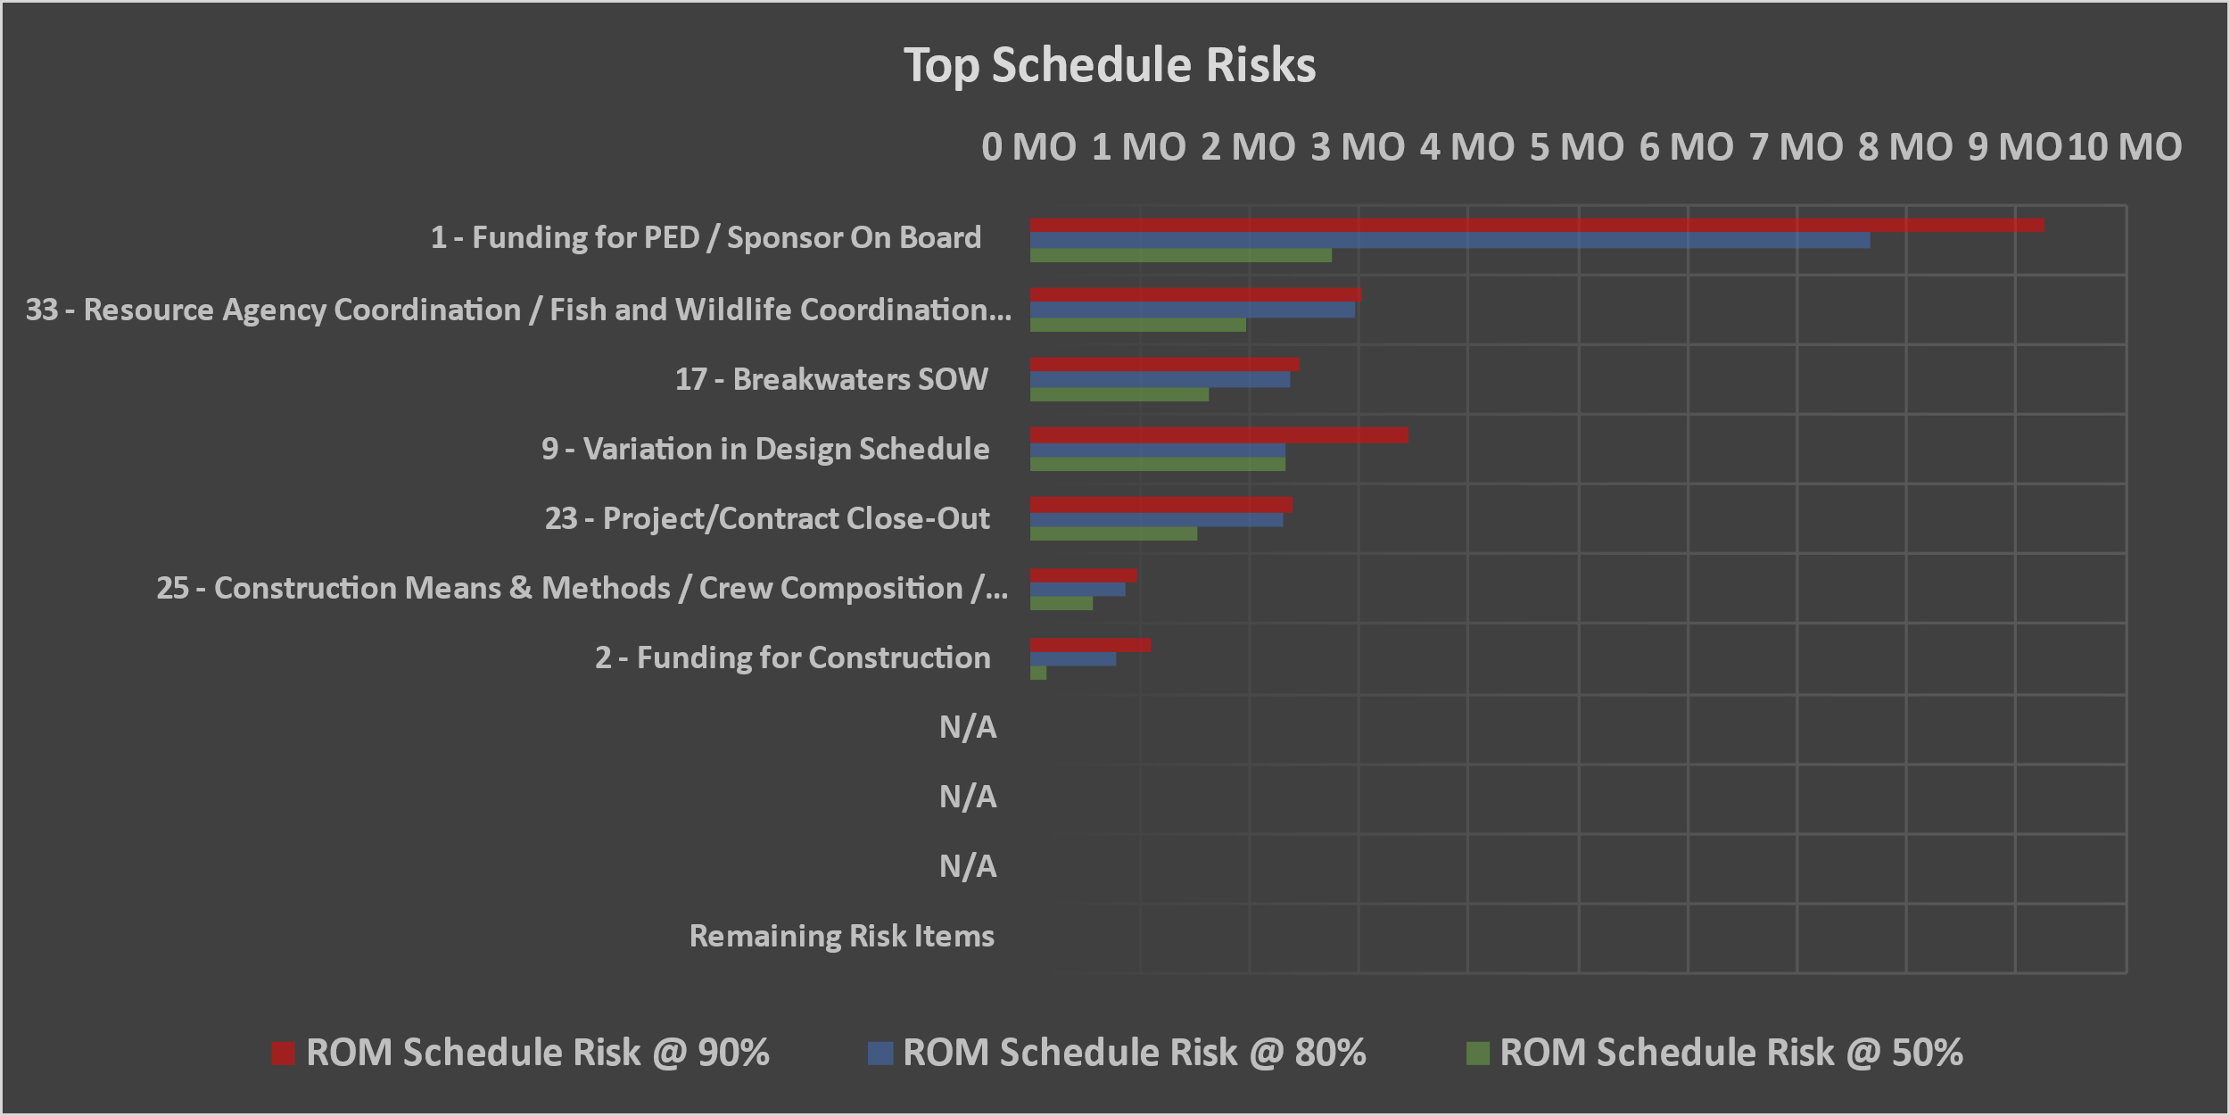

Figure 4. Top Schedule Risks

* **Risk 1: Funding for PED / Sponsor on Board.** It is uncertain whether all needed Congressional funding for PED will be made available in a timely manner. A sponsor has not yet been identified yet and PED cannot start until this is complete.
* **Risk 33: Resource Agency Coordination / Fish and Wildlife Coordination Act / Compliance with the Endangered Species Act.** Coordination with other agencies could delay our study or design schedule. To be in compliance, we must receive a Coordination Act Report (CAR) from the USFWS which has not started yet so any delays could impact completion of the study and delay design/implementation. While a meeting was hosted with the agencies (USFWS and NMFS) to discuss issues and adopt all their recommendations into our design, the project still has elements that occur in critical habitat for Piping Plover and habitat for other protected species (like the Whooping Crane, West Indian Manatee, and sea turtle species) which could impact the cost or schedule."
* **Risk 17: Breakwaters**. There is limited survey data and the design height could change resulting in quantity changes. If area is too shallow, additional dredging may be needed. Stone is intended to be placed on the river bottom. The alignment could also shift closer/further from the channel to best match the survey data.
* **Risk 9: Variation in Design Schedule.** Risks related to delays in design due to longer review times, potential re-design efforts, environmental reviews, etc.
* **Risk 23: Project/Contract Close-Out**. The duration needed for dealing with any remaining mods, claims, etc. could delay fiscal completion.
* **Risk 25: Construction Means & Methods / Crew Composition / Production Rates**. Estimated production rates could vary as well as the assumed number of crews working concurrently. Major activities are rip rap placement & dredging.
* **Risk 2: Funding for Construction.** If project is not fully funded up-front, certain components could have emphasis to be constructed first with others possibly being delayed.

See Appendix C for additional details for these risks and further information regarding CSRA development.

# Recommendations, Risk Management, & Updates

## Recommendations

Risk Management is an all-encompassing, iterative, and life-cycle process of project management. The Project Management Institute’s (PMI) *A Guide to the Project Management Body of Knowledge (PMBOK® Guide)*, *Sixth Edition*, states that “project risk management includes the processes of conducting risk management planning, identification, analysis, response planning, response implementation, and monitoring risk on a project.” Risk identification and analysis are processes within the knowledge area of risk management. Its outputs pertinent to this effort include the risk register, risk quantification (risk analysis model), contingency report, and the sensitivity analysis.

The intended use of these outputs is implementation by the project leadership with respect to risk responses (such as mitigation) and risk monitoring and control. In short, the effectiveness of the project risk management effort requires that the proactive management of risks not conclude with the study completed in this report.

The CSRA produced by the PDT identifies issues that require the development of subsequent risk response and mitigation plans. This section provides a list of recommendations for continued management of the risks identified and analyzed in this study. Note that this list is not all inclusive and should not substitute a formal risk management and response plan.

The CSRA study serves as a “road map” towards project improvements and reduced risks over time. The PDT should include the recommended cost and schedule contingencies and incorporate risk monitoring and mitigation on those identified risks. Further iterative study and update of the risk analysis throughout the project life cycle is important in support of remaining within an approved budget and appropriation.

## Risk Management

Project leadership should use of the outputs created during the risk analysis effort as tools in future risk management processes. The risk register should be updated at each major project milestone. The results of the sensitivity analysis may also be used for response planning strategy and development. These tools should be used in conjunction with regular risk review meetings.

## Risk Analysis Updates

Project leadership should review risk items identified in the original risk register and add others, as required, throughout the project life cycle. Risks should be reviewed for status and reevaluation (using qualitative measure, at a minimum) and placed on risk management watch lists if any risk’s likelihood or impact significantly increases. Project leadership should also be mindful of the potential for secondary (new risks created specifically by the response to an original risk) and residual risks (risks that remain and have unintended impact following response).



Base Estimate



Base Schedule



Cost & Schedule Risk Analysis Details

Risk Dashboards

Contingency Summary

Sensitivity Charts

Risk Register

CSRA Assumptions

Risk Register Attendance

Risk Details

*If Applicable -OR- Available Upon Request*