**Do Not Print This Page – Template Instructions**

1. Update project information below. This should update many of the project specific information and headers/footers in the template.

|  |  |
| --- | --- |
| Description | Information |
| Agency: | **Agency** |
| Prepared for: | **District** |
| Prepared by: | **Cost Engineering Technical Center of Expertise, Walla Walla, WA** |
| Project Name: | **Project Name** |
| Location: | **City, XX** |
| Title: | **2022 Current Working Estimate (CWE)** |
| Date of CSRA Report: | **October 2022** |
| Risk Register Meeting Date: | **10/1/2022** |
| Confidence Level of CSRA: | **50%** |

1. Update the logo on this page header to the appropriate agency.
2. Update the project photo on the cover page.
3. Update Section 2, Project Scope. Recommend listing the current status of the project, project scope, and any other pertinent information specific to the project. This information is highlighted yellow.
4. Update Section 3, Key Assumptions. Recommend listing anything that could drastically affect the analysis such as: concerns, inclusions, exclusions, geotechnical analysis, H&H analysis, surveying, acquisition strategy, funding, etc. If contingencies were provided by others, recommend documenting that information as well. This information is highlighted yellow.
5. Update the cost & schedule values, contingencies, price levels, etc. in Section 7.1; information is highlighted yellow.
6. Update top cost risk item bullets in Section 7.2.2; information is highlighted yellow.
7. Update top schedule risk item bullets in Section 7.3.2; information is highlighted yellow.
8. Update all figures and tables throughout the document as they relate to your project.
9. For Appendixes A & B, recommend providing a short 1-2 page summary of the base estimate and high-level 1-2 page summary of the base schedule which supports this CSRA.
10. Update Table of Contents & page number references. ***Tip to update entire document 🡪 Press ‘Ctrl + A’, Press ‘F9”, Select “Update entire table” (multiple times for TOC, figures, & tables).***
11. Print this report to PDF. From the MS Excel CSRA file, print the risk dashboards (Appendix C-1), contingency summary (Appendix C-2), sensitivity charts (Appendix C-3), risk register (Appendix C-4), CSRA assumptions (Appendix C-5), risk register attendance (Appendix C-6), and risk details (Appendix C-7) to PDF and append the information to the report PDF document.

**Project Name**

**City, XX**

**CSRA for 2022 Current Working Estimate (CWE)**

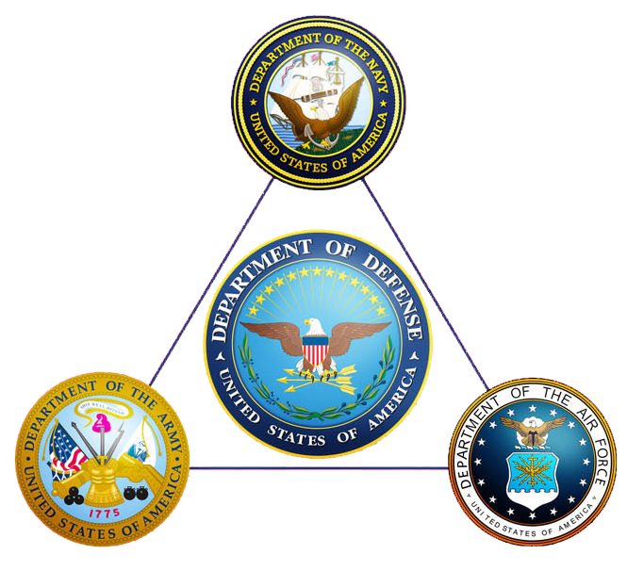

**Prepared by:**

***Agency***

***Cost Engineering Technical Center of Expertise, Walla Walla, WA***

***October 2022***

**Table of Contents**

1. Purpose 1

2. Project Scope 1

3. Key Assumptions 1

4. Cost & Schedule Risk Analysis Process 1

5. Base Estimate 1

6. Base Schedule 2

7. Cost & Schedule Risk Analysis 2

7.1. Summary of Results 2

7.2. Cost Risk Analysis 3

7.3. Schedule Risk Analysis 5

8. Recommendations, Risk Management, & Updates 7

8.1. Recommendations 7

8.2. Risk Management 7

8.3. Risk Analysis Updates 7

**Figures**

Figure 1. Cost Contingency Levels 3

Figure 2. Top Cost Risks 4

Figure 3. Schedule Contingency Levels 5

Figure 4. Top Schedule Risks 6

**Tables**

Table 1. Summary of CSRA Results 3

Table 2. Cost Confidence Levels 3

Table 3. Schedule Confidence Levels 5

**Appendixes**

Appendix A: Base Estimate

Appendix B: Base Schedule

Appendix C: Cost & Schedule Risk Analysis Details

# Purpose

The Agency, District, presents this Cost and Schedule Risk Analysis (CSRA) report regarding the risk findings and recommended contingencies for the Project Name 2022 Current Working Estimate (CWE). A *Monte-Carlo* based risk analysis was conducted by the Project Delivery Team (PDT) on remaining costs in compliance with UFC 3-740-05, Construction Cost Estimating. The purpose of this risk analysis study is to present the cost and schedule risks considered and respective project contingencies at a recommended 50% confidence level of successful execution to project completion.

# Project Scope

Recommend providing a brief summary of the project location, background, major scope items, assumed contract acquisition strategy, etc.

# Key Assumptions

Recommend documenting key assumptions regarding the analysis. Some common examples are:

* Funding. Are there funding limitations or potential delays in acquiring funding?
* Sponsor. Is there a sponsor involved? Do their capabilities impact funding on when work can be performed if activities need to be completed by the sponsor?
* Contract Acquisition Strategy. How many contracts will there be to execute the project?
* Construction vs. Total Project. Is the CSRA evaluating just construction or the total project which could include real estate, design, engineering during construction, construction management, etc.? This sometimes varies based on what was requested.
* Contingency Sources. Sometimes contingencies are provided to the cost engineer and not varied in the CSRA. Example, real estate contingencies on many USACE projects are provided by the Real Estate Community of Practice (CoP). Still recommend evaluating the schedule risks for these items since it could increase risk to other project components.
* Geotechnical. Have investigative drilling or studies been conducted which support the design? If this data is not currently available, it could drastically impact scope, cost, and schedule if it varies much from the current assumptions.
* Hydraulics & Hydrology. Has hydraulic modeling or studies been conducted which support the design? If this data is not currently available, it could drastically impact scope, cost, and schedule if it varies much from the current assumptions.
* Surveying/Mapping. Does recent survey or mapping data support quantity development?
* Construction Schedule. Has a construction schedule been developed that factors in weather days, work calendars, holidays, winter shutdown periods, work window restrictions, constraints, lead-times, non-construction activities, etc. which could impact the implementation schedule?

# Cost & Schedule Risk Analysis Process

Refer to Chapter 14 of the UFC 3-740-05, Construction Cost Estimating, which details out the overview, responsibilities, documentation, process, review, market analysis, risk register, modeling, and deliverables required in developing the CSRA.

# Base Estimate

See Appendix A for a summary of the base cost estimate from which this CSRA was conducted.

# Base Schedule

See Appendix B for a summary of the base schedule from which this CSRA was conducted.

# Cost & Schedule Risk Analysis

The CSRA results are provided in the following sections. In addition to contingency calculation results, the top cost and schedule risks were identified, and sensitivity analyses are presented to provide decision makers with:

* An understanding of variability and the key contributors,
* Contingency information for scheduling, budgeting, and project control purposes, and
* Provide tools to support decision making and risk management as projects progress through planning and implementation.

Additional information and details can be found in various Appendix C subsections which are described below.

* **Appendix C-1: Risk Dashboards.** Summary of the top cost & schedule risk items, confidence levels, and suggested risk reduction measures.
* **Appendix C-2: Contingency Summary.** Summary of the various contingency values for cost & schedule by confidence level.
* **Appendix C-3: Sensitivity Charts.** Summary of the major cost & schedule risk items along with a graphical representation of their potential range of impacts at the 50%, 80%, and 90% confidence levels.
* **Appendix C-4: Risk Register.** Summary of the risk register documenting risk type, risk details, likelihood, impact ratings, responsibility, suggested risk reduction measures, etc.
* **Appendix C-5: CSRA Assumptions.** Summary of the risk matrix, likelihood of occurrence definition, impact or consequence definitions for cost / schedule, and cost / schedule impact ranges as they relate to this project.
* **Appendix C-6: Risk Register Attendance.** Summary of the participants of the risk register meeting which was conducted on 10/1/2022.
* **Appendix C-7: Risk Details (if applicable).** Some projects and their risk items could require more complex calculations to determine their risk impact ranges. This is not a mandatory requirement, but risk detail sheets are sometimes developed to help document these assumptions and calculations. These risk detail sheets are typically not included by default but can be available upon request.

## Summary of Results

The current remaining construction cost is approximately $297.9M excluding contingency and expressed in FY2023 dollars. Based on the results of the analysis, the **CSRA recommends a contingency value of $83.4M, or approximately 28% of base project cost at an** 50% **confidence level of successful execution. The current project base construction schedule is approximately 65 months excluding contingency. Based on the results of the analysis,** the **CSRA recommends a contingency value of almost 8.4 months, or approximately 13% of base project schedule at an** 50% **confidence level of successful execution.** See Table 1 below for a more detailed summary and Appendix C for additional details regarding risk-based contingency development.

Table 1. Summary of CSRA Results





## Cost Risk Analysis

### Cost Confidence Levels

The result of risk or uncertainty analysis is quantification of the cumulative impact of all analyzed risks or uncertainties as compared to probability of occurrence. These results, as applied to the analysis herein, depict the overall project cost at intervals of confidence (probability). Table 2 provides the cost contingencies calculated for the various confidence levels with the 50% confidence level highlighted. Figure 1 presents this information graphically. Contingencies are rounded up to the nearest whole percentage.

Table 2. Cost Confidence Levels

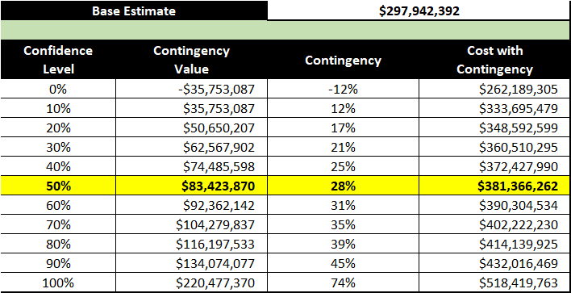

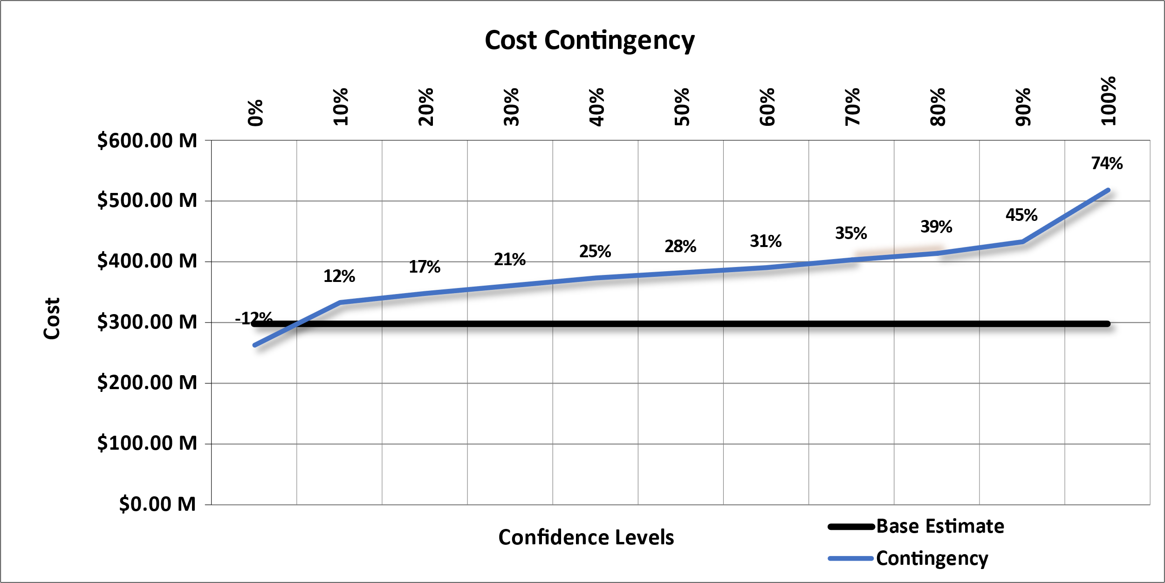

Figure . Cost Contingency Levels

### Top Cost Risks

The risks/opportunities considered as key or primary cost drivers are ranked in order of potential impact (positive or negative) in Figure 2 at various confidence levels (50%, 80%, and 90%). Opportunities that have a potential to reduce project cost and are shown with a negative sign to reflect the potential to decrease project cost; risks are shown with a positive sign to reflect the potential to increase project cost. These key cost drivers can be used to support development of a risk management plan that will facilitate control of risk factors and their potential impacts throughout the project lifecycle. Together with the risk register, these results can also be used to support development of strategies to eliminate, mitigate, accept, or transfer key risks. See Appendix C for additional details for these risks and further information regarding CSRA development.

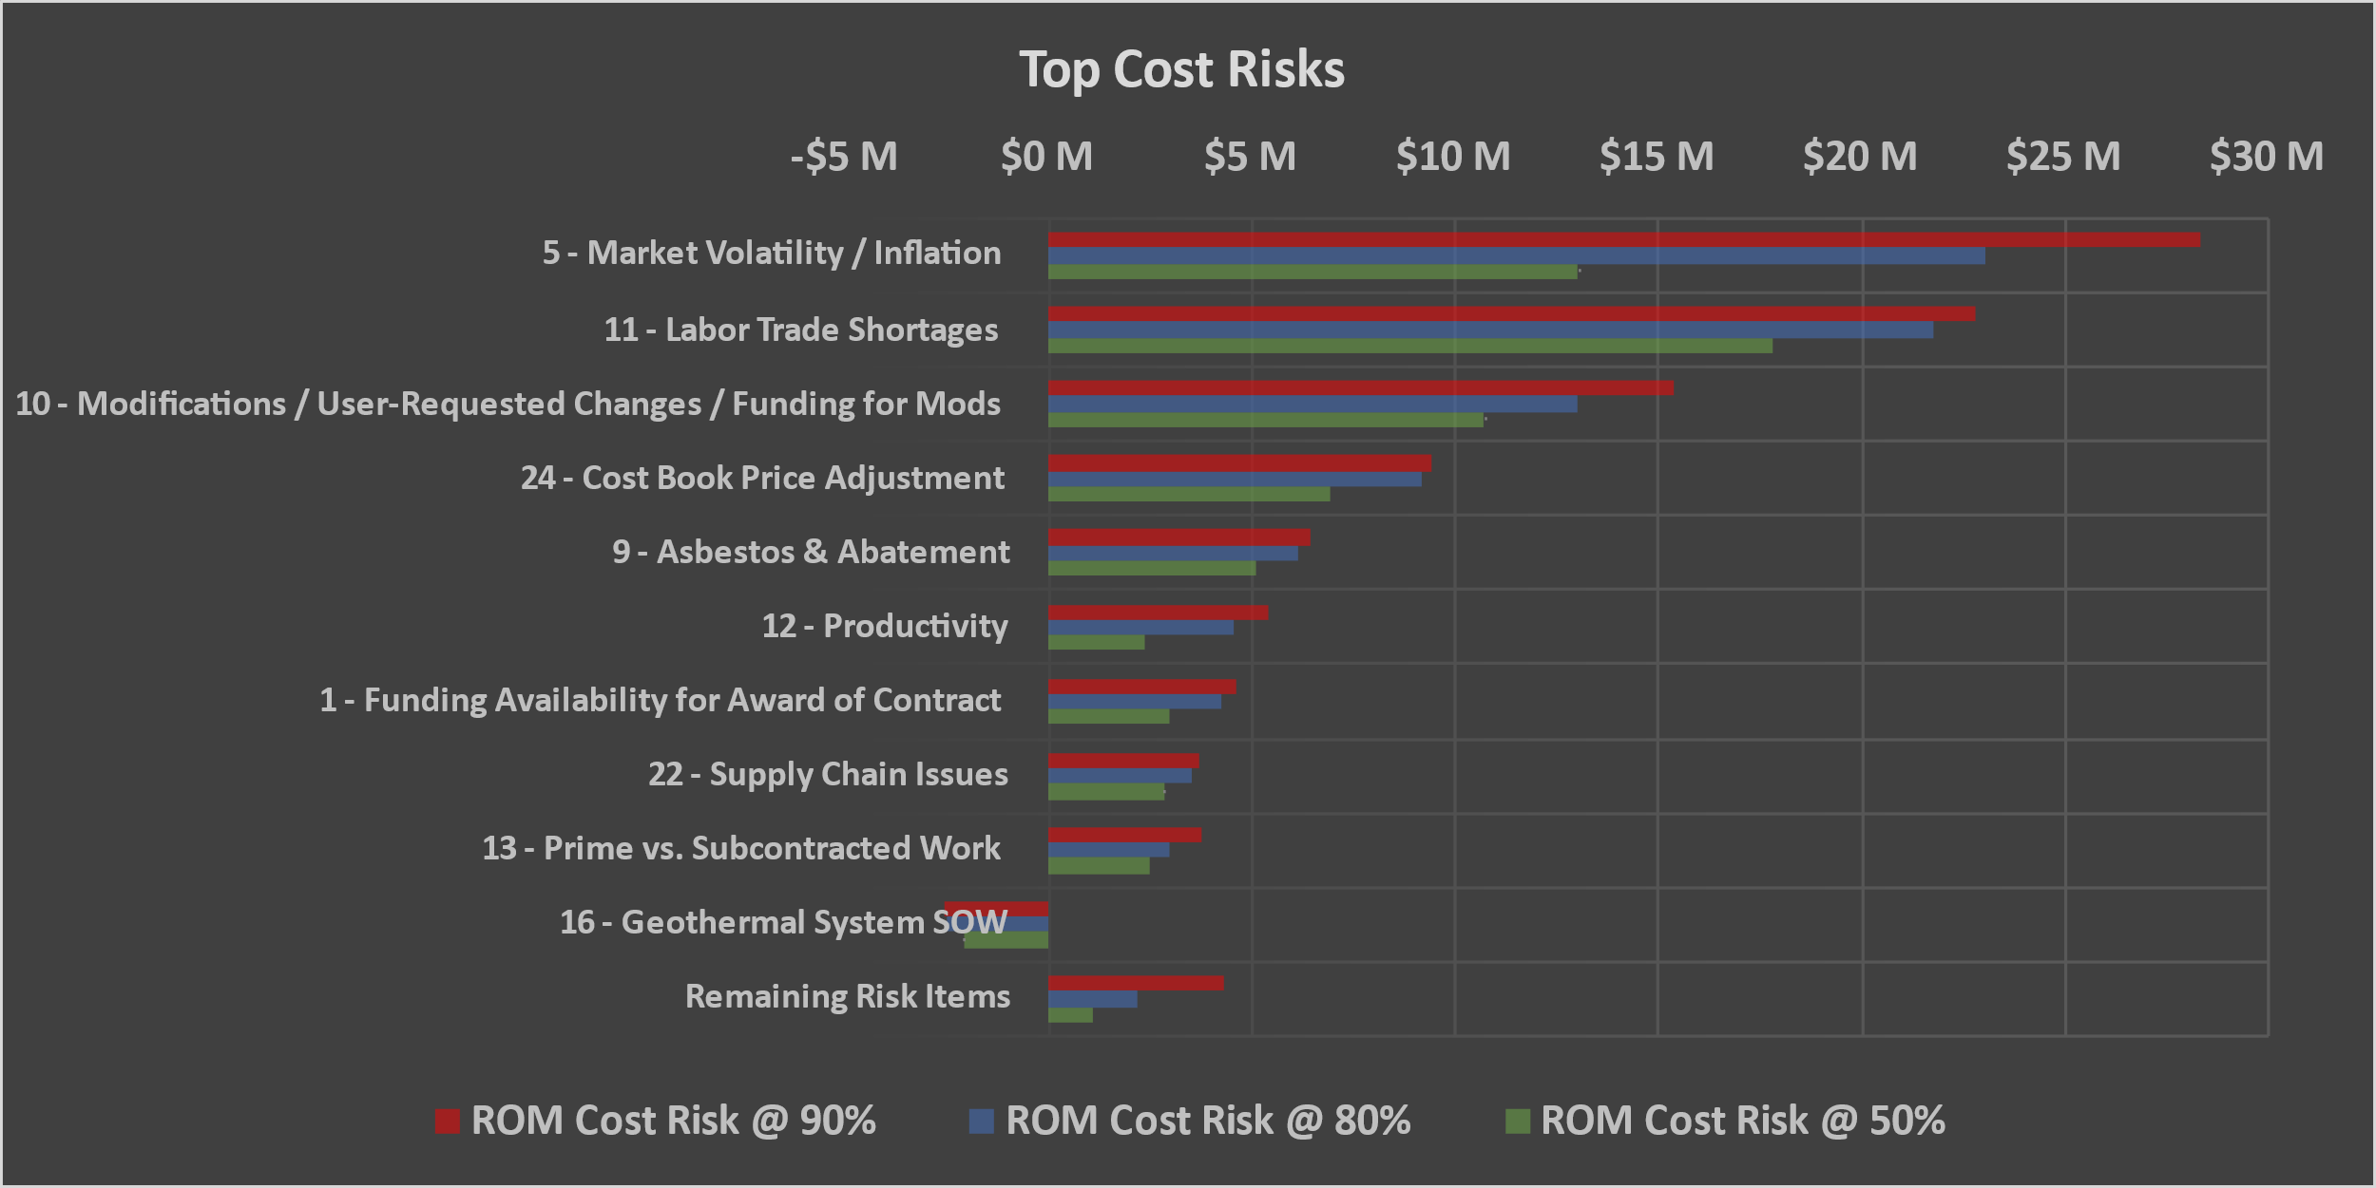

Figure 2. Top Cost Risks

* **Risk 5: Market Volatility / Inflation.** Escalation percentages to get to midpoint of construction; there is a lot of volatility in the market right now. The current future projection has inflation at approximately 3% per year but the latest ENR Building Cost Index 3-year trend is about 7.2% for the Denver, CO area.
* **Risk 11: Labor Trade Shortages.** Primarily related to roofers, concrete, and electricians but it depends on how much work is taking place in Denver. There could be additional labor costs for per diem or productivity impacts if not enough trade is available to achieve the higher production rates.
* **Risk 10: Modifications / User-Requested Changes / Funding for Mods.** Modifications exist on every project. The availability of funding and time it takes to receive funding for change orders could also impact the cost and schedule as well.
* **Risk 24: Cost Book Price Adjustment.** The estimate is heavily based on the 2016 Cost Book for which material pricing has to be adjusted. Building materials since COVID hit have been very volatile with pricing.
* **Risk 9: Asbestos & Abatement.** Full abatement is currently not included in the estimate or schedule. Doing demolition and investigation early on in construction can help identify what work could be anticipated. If full abatement is needed, it could affect cost and schedule.
* **Risk 12: Productivity.** This could be impacted by availability of trade workers as mentioned in Risk 11. The base estimate assumes 70% productivity factor which is typical for renovation work. Because construction is in an occupied building, there are certain restrictions which would impact productivity.
* **Risk 1: Funding Availability for Award of Contract.** The DD1391 is currently based on the original 65% cost estimate but the CSRA process has resulted in an updated estimate which is higher. The intent is to update the DD1391 with the most current estimate projections. Another concern is that there is currently no funding for modifications which are very likely to occur. If approval of the current DD1391 does not happen before the award date, it could delay the project by a year.
* **Risk 22: Supply Chain Issues.** Longer lead times could affect cost or schedule. Many long lead items already identified in schedule which drive the construction duration. Shortening the lead time may cost more due to having to pay premiums.
* **Risk 13: Prime vs. Subcontracted Work.** If the Prime Contractor is outside the area, sometimes they have trouble getting subcontractors to work with them. What work is performed by the Prime Contractor or Subcontractors can also vary along with the associated indirect markups (Field Office, Home Office, Profit, & Bond).
* **Risk 16: Geothermal System SOW.** The base schedule assumes two rigs with 6 months to install and is on the critical path. If multiple drilling rigs cannot be acquired to install the system, it could possibly increase the critical path to the construction schedule.

## Schedule Risk Analysis

### Schedule Confidence Levels

The result of risk or uncertainty analysis is quantification of the cumulative impact of all analyzed risks or uncertainties as compared to probability of occurrence. These results, as applied to the analysis herein, depict the overall project duration at intervals of confidence (probability). Table 3 provides the schedule duration contingencies calculated for the various confidence levels with the 50% confidence level highlighted. Contingencies are rounded up to the nearest whole percentage.

Table 3. Schedule Confidence Levels

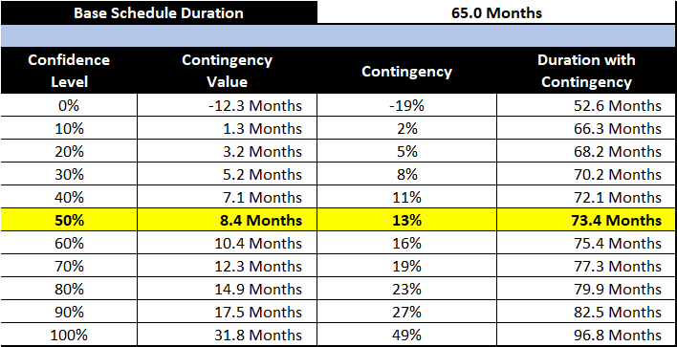

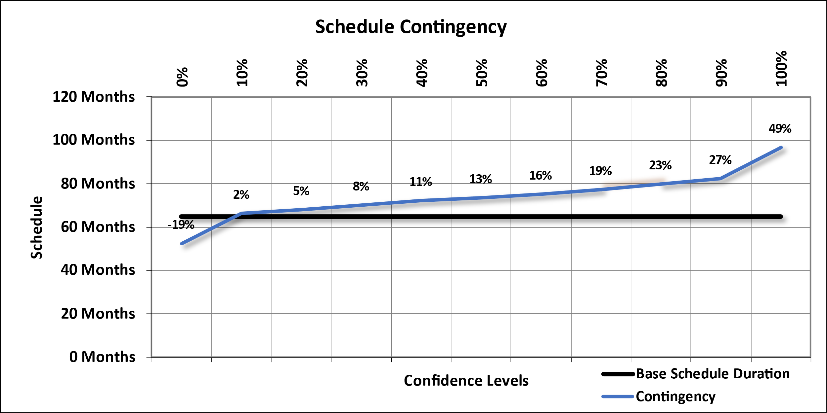

Figure . Schedule Contingency Levels

These contingencies were also used to calculate the projected residual fixed cost impact of project delays that are included in the Table 2 presentation of total cost contingency. The schedule contingencies were calculated by applying the high-level schedule risks identified in the risk register for each option to the durations of critical path and near critical path tasks.

The schedule was not resource loaded and contained open-ended tasks and non-zero lags (gaps in the logic between tasks) that limit the overall utility of the schedule risk analysis. These issues should be considered as limitations in the utility of the schedule contingency data presented. Schedule contingency impacts presented in this analysis are based solely on projected residual fixed costs.

### Top Schedule Risks

The risks/opportunities considered as key or primary schedule drivers are ranked in order of potential impact (positive or negative) in Figure 4 at various confidence levels (50%, 80%, and 90%). Opportunities that have a potential to reduce project schedule and are shown with a negative sign to reflect the potential to decrease project duration; risks are shown with a positive sign to reflect the potential to increase project duration. These key schedule drivers can be used to support development of a risk management plan that will facilitate control of risk factors and their potential impacts throughout the project lifecycle. Together with the risk register, sensitivity analysis results can also be used to support development of strategies to eliminate, mitigate, accept, or transfer key risks. See Appendix C for additional details for these risks and further information regarding CSRA development.

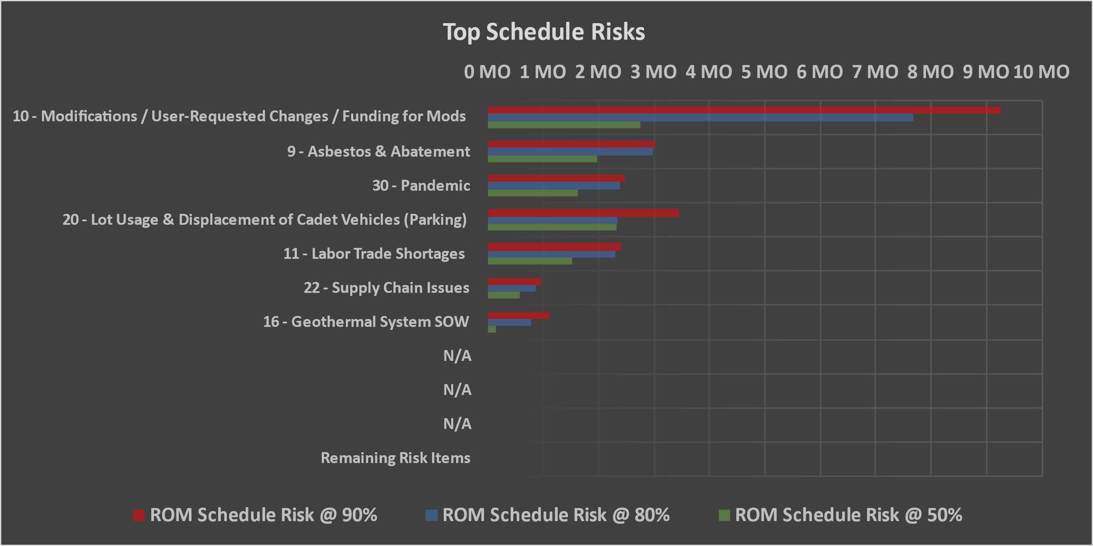

Figure 4. Top Schedule Risks

* **Risk 10: Modifications / User-Requested Changes / Funding for Mods.** Modifications exist on every project. The availability of funding and time it takes to receive funding for change orders could also impact the cost and schedule as well.
* **Risk 9: Asbestos & Abatement.** Full abatement is currently not included in the estimate or schedule. Doing demolition and investigation early on in construction can help identify what work could be anticipated. If full abatement is needed, it could affect cost and schedule.
* **Risk 30: Pandemic.** Pandemic outbreaks could cause delays to construction or availability of materials.
* **Risk 20: Lot Usage & Displacement of Cadet Vehicles (Parking)**. If the location of lay down areas or there are changes in assumptions related to how the existing lots are going to be used for contractor access, this could affect cost or schedule related to additional work which may be needed for other laydown areas or the number of productive working hours in a day if the contractor has to stage employees further away.
* **Risk 11: Labor Trade Shortages.** Primarily related to roofers, concrete, and electricians but it depends on how much work is taking place in Denver. There could be additional labor costs for per diem or productivity impacts if not enough trade is available to achieve the higher production rates.
* **Risk 22: Supply Chain Issues.** Longer lead times could affect cost or schedule. Many long lead items already identified in schedule which drive the construction duration. Shortening the lead time may cost more due to having to pay premiums.
* **Risk 16: Geothermal System SOW.** The base schedule assumes two rigs with 6 months to install and is on the critical path. If multiple drilling rigs cannot be acquired to install the system, it could possibly increase the critical path to the construction schedule.

# Recommendations, Risk Management, & Updates

## Recommendations

Risk Management is an all-encompassing, iterative, and life-cycle process of project management. The Project Management Institute’s (PMI) *A Guide to the Project Management Body of Knowledge (PMBOK® Guide)*, *Sixth Edition*, states that “project risk management includes the processes of conducting risk management planning, identification, analysis, response planning, response implementation, and monitoring risk on a project.” Risk identification and analysis are processes within the knowledge area of risk management. Its outputs pertinent to this effort include the risk register, risk quantification (risk analysis model), contingency report, and the sensitivity analysis.

The intended use of these outputs is implementation by the project leadership with respect to risk responses (such as mitigation) and risk monitoring and control. In short, the effectiveness of the project risk management effort requires that the proactive management of risks not conclude with the study completed in this report.

The CSRA produced by the PDT identifies issues that require the development of subsequent risk response and mitigation plans. This section provides a list of recommendations for continued management of the risks identified and analyzed in this study. Note that this list is not all inclusive and should not substitute a formal risk management and response plan.

The CSRA study serves as a “road map” towards project improvements and reduced risks over time. The PDT should include the recommended cost and schedule contingencies and incorporate risk monitoring and mitigation on those identified risks. Further iterative study and update of the risk analysis throughout the project life cycle is important in support of remaining within an approved budget and appropriation.

## Risk Management

Project leadership should use of the outputs created during the risk analysis effort as tools in future risk management processes. The risk register should be updated at each major project milestone. The results of the sensitivity analysis may also be used for response planning strategy and development. These tools should be used in conjunction with regular risk review meetings.

## Risk Analysis Updates

Project leadership should review risk items identified in the original risk register and add others, as required, throughout the project life cycle. Risks should be reviewed for status and reevaluation (using qualitative measure, at a minimum) and placed on risk management watch lists if any risk’s likelihood or impact significantly increases. Project leadership should also be mindful of the potential for secondary (new risks created specifically by the response to an original risk) and residual risks (risks that remain and have unintended impact following response).



Base Estimate



Base Schedule



Cost & Schedule Risk Analysis Details

Risk Dashboards

Contingency Summary

Sensitivity Charts

Risk Register

CSRA Assumptions

Risk Register Attendance

Risk Details

*If Applicable -OR- Available Upon Request*