UNIFIED FACILITIES CRITERIA (UFC)

DRAFT
TITLE IN UPPER CASE

APPROVED FOR PUBLIC RELEASE; DISTRIBUTION UNLIMITED
PRE-DECISIONAL; NOT FOR PUBLIC RELEASE

Use blank pages to ensure the front matter pages start on side one of a two sided printout.

Section breaks are utilized so the vertical alignment of this page can be set to be centered in page setup. To accomplish this, go to Page Setup > Layout tab > under Page > Vertical alignment > choose Center. Make sure the following page has the Vertical alignment set back to Top.

This Page Intentionally Left Blank

UNIFIED FACILITIES CRITERIA (UFC)

DRAFT TITLE IN UPPERCASE

Any copyrighted material included in this UFC is identified at its point of use.
Use of the copyrighted material apart from this UFC must have the permission of the copyright holder.

Indicate the Military Department Preparing Activity responsible for the document.

U.S. ARMY CORPS OF ENGINEERS
NAVAL FACILITIES ENGINEERING SYSTEMS COMMAND (Preparing Activity)
AIR FORCE CIVIL ENGINEER CENTER

Record of Changes (changes are indicated by \1\ ... /1/)
Change No. | Date | Location

This UFC supersedes UFC X-XXX-XX, dated m yyyy.

This Page Intentionally Left Blank

FOREWORD

The Unified Facilities Criteria (UFC) system is prescribed by MIL-STD 3007 and provides planning, design, construction, sustainment, restoration, and modernization criteria, and applies to the Military Departments, the Defense Agencies, and the DoD Field Activities in accordance with USD (AT&L) Memorandum dated 29 May 2002. UFC will be used for all DoD projects and work for other customers where appropriate. All construction outside of the United States, its territories, and possessions is also governed by Status of Forces Agreements (SOFA), Host Nation Funded Construction Agreements (HNFA), and in some instances, Bilateral Infrastructure Agreements (BIA). Therefore, the acquisition team must ensure compliance with the most stringent of the UFC, the SOFA, the HNFA, and the BIA, as applicable.
UFC are living documents and will be periodically reviewed, updated, and made available to users as part of the Military Department’s responsibility for providing technical criteria for military construction. Headquarters, U.S. Army Corps of Engineers (HQUSACE), Naval Facilities Engineering Systems Command (NAVFAC), and Air Force Civil Engineer Center (AFCEC) are responsible for administration of the UFC system. Technical content of UFC is the responsibility of the cognizant DoD working group. Defense Agencies should contact the respective DoD Working Group for document interpretation and improvements. Recommended changes with supporting rationale may be sent to the respective DoD working group by submitting a Criteria Change Request (CCR) via the Internet site listed below.
UPDATE FORWARD TO CURRENT TEMPLATE
PRIOR TO PUBLICATION
UFC are effective upon issuance and are distributed only in electronic media from the following source:
- Whole Building Design Guide website https://www.wbdg.org/ffc/dod.
Refer to UFC 1-200-01, DoD Building Code, for implementation of new issuances on projects.
AUTHORIZED BY:

PETE G. PEREZ, P.E., SES  Chief, Engineering and Construction  U.S. Army Corps of Engineers |  | S. KEITH HAMILTON, P.E., SES  Chief Engineer and Director  Planning, Design and Construction  Naval Facilities Engineering Systems Command
DAVID H. DENTINO, SES  Deputy Director of Civil Engineers  DCS/Logistics, Engineering &  Force Protection (HAF/A4C)  HQ United States Air Force |  | MICHAEL McANDREW, SES  Deputy Assistant Secretary of Defense (Infrastructure Modernization and Resilience)  Office of the Secretary of Defense

This Page Intentionally Left Blank

Previous versions of UFCs contained Summary Sheet. This has been deleted. See info at the end of the Template.
Table of Contents, Table of Figures, and Table of Tables are automatically generated when the field is updated utilizing the Table of Contents features in Microsoft Word. Only the number, title and page number should appear. If text, figures or tables are visible, they are not linked to the appropriate Style such as UFCtext.
Table of Contents should include chapter titles, major paragraph titles and first level subparagraph titles. This may be expanded to include second level subparagraphs only when it is required based on document content.

TABLE OF CONTENTS
CHAPTER 1 INTRODUCTION 1
1-1 BACKGROUND. 1
1-2 REISSUES AND CANCElS. 1
1-3 Incorporates and Cancels. 1
1-4 PURPOSE AND SCOPE. 1
1-5 APPLICABILITY. 1
1-6 GENERAL BUILDING REQUIREMENTS. 1
1-7 CYBERSECURITY. 2
1-8 GLOSSARY. 2
1-9 REFERENCES. 2
CHAPTER 2 TECHNICAL REQUIREMENTS 3
2-1 MAJOR PARAGRAPH TITLE. 3
2-1.1 First level subparagraph title. 3
2-1.2 First level subparagraph title. 3
2-1.3 First level subparagraph title. 3
2-2 FIGURES. 3
2-3 TABLES. 4
2-4 EQUATIONS. 5
2-5 BULLETED LISTS. 6
2-6 COMMENTARY. 6
2-7 FUNCTIONAL DATA SHEET. 6
CHAPTER 3 DESIGN 9
3-1 MAJOR PARAGRAPH TITLE. 9
3-1.1 First level subparagraph title. 9
3-2 MAJOR PARAGRAPH TITLE. 9
3-2.1 First level subparagraph title. 9
3-3 MAJOR PARAGRAPH TITLE. 9
3-4 MAJOR PARAGRAPH TITLE. 9
3-4.1 First level subparagraph title. 9
3-4.2 First level subparagraph title. 9
CHAPTER 4 TITLE 11
4-1 MAJOR PARAGRAPH TITLE. 11
APPENDIX A BEST PRACTICES 13
A-1 MAJOR PARAGRAPH TITLE. 13
A-1.1 First level subparagraph title. 13
A-2 MAJOR PARAGRAPH TITLE. 13
A-2.1 First level subparagraph title. 13
A-3 MAJOR PARAGRAPH TITLE. 14
A-4 MAJOR PARAGRAPH TITLE. 14
A-5 MAJOR PARAGRAPH TITLE. 14
APPENDIX B GLOSSARY 15
B-1 ACRONYMS. 15
B-2 DEFINITION OF TERMS. 16
APPENDIX C REFERENCES 17

FIGURES
Figure 2-1 Example Figure 6
Figure 2-2 Example Using a 2x1 Table to Align Graphics 6
Figure 2-3 Example Functional Data Sheet 9

TABLES
Table 2-1 Example Table 7

This is a Microsoft word template intended to be used in conjunction with UFC 1-300-01, Criteria Format Standard. The intent is to create uniformly formatted documents with the ability to generate Table of Contents and cross references using embedded styles. This template includes customized Styles for chapter headings, subparagraphs, figure titles, table titles, bulleted lists, equation titles, commentary, and general text with custom multilevel lists. Do not modify the customized styles or the multilevel lists linked to the styles in this document.
When reformatting an existing document into the Word Template, the best approach is to copy and paste the content from the original document into this template utilizing the “Keep Text Only (T)” option in Word. This will ensure that no conflicting Word Styles or custom multilevel lists will be introduced into the document.
When editing a document make sure the Navigation Pane is turned on. The Navigation Pane contains links to all the chapters, paragraphs, figures and tables which makes it easy to navigate through the document.
- INTRODUCTION
  - BACKGROUND.
Provide subparagraph and text if applicable.
  - REISSUES AND CANCElS.
Required, for criteria updates. If the document is a new UFC, remove the entire paragraph.
  - Incorporates and Cancels.
Required, for UFCs incorporating and cancelling documents. If the issuance is not incorporating and cancelling another document, remove the entire paragraph.
  - PURPOSE AND SCOPE.
Description of purpose and scope.
  - APPLICABILITY.
Description of applicability.
  - GENERAL BUILDING REQUIREMENTS.
Comply with UFC 1-200-01, DoD Building Code. UFC 1-200-01 provides applicability of model building codes and government unique criteria for typical design disciplines and building systems, as well as for accessibility, antiterrorism, security, high performance and sustainability requirements, and safety. Use this UFC in addition to UFC 1-200-01 and the UFCs and government criteria referenced therein.
  - CYBERSECURITY.
All facility-related control systems (including systems separate from a utility monitoring and control system) must be planned, designed, acquired, executed, and maintained in accordance with UFC 4-010-06, and as required by individual Service Implementation Policy.
  - GLOSSARY.
APPENDIX B contains acronyms, abbreviations, and terms.
  - REFERENCES.
APPENDIX C contains a list of references used in this document. The publication date of the code or standard is not included in this document. Unless otherwise specified, the most recent edition of the referenced publication applies.

- TECHNICAL REQUIREMENTS
Style for Chapter Titles is UFCchapter
  - MAJOR PARAGRAPH TITLE.
Style for Major Paragraph Titles is UFCpara1. Style for paragraph text is UFCtext.
    - First level subparagraph title.
Style for First level subparagraph titles is UFCpara2. Style for paragraph text is UFCtext.
    - First level subparagraph title.
Style for First level subparagraph titles is UFCpara2. Style for paragraph text is UFCtext.
    - First level subparagraph title.
Style for First level subparagraph titles is UFCpara2. Style for paragraph text is UFCtext.
      - Second level subparagraph title.
Style for second level subparagraph titles; if used, is UFCpara3. Style for paragraph text is UFCtext.
      - Second level subparagraph title.
Style for second level subparagraph titles; if used, is UFCpara3. Style for paragraph text is UFCtext.
        - Third level subparagraph title.
Style for Third level subparagraph titles; if used, is UFCpara4. Style for paragraph text is UFCtext.
        - Third level subparagraph title.
Style for Third level subparagraph titles; if used, is UFCpara4. Style for paragraph text is UFCtext.
  - FIGURES.
Style for figure titles is UFCfigure. Style for the actual figure is UFCtext + Centered. Per UFC 1-300-01, Font size may be reduced to a minimum 8-point. See Figure 2-1. If using multiple graphics for one figure, use a table to align graphics. Example is shown in Figure 2-2. Utilize the cross-reference capability in Word to link the text reference to the appropriate figure. This will allow for the future insertion of Figures and the reference will update when the fields are updated.
            - Example Figure
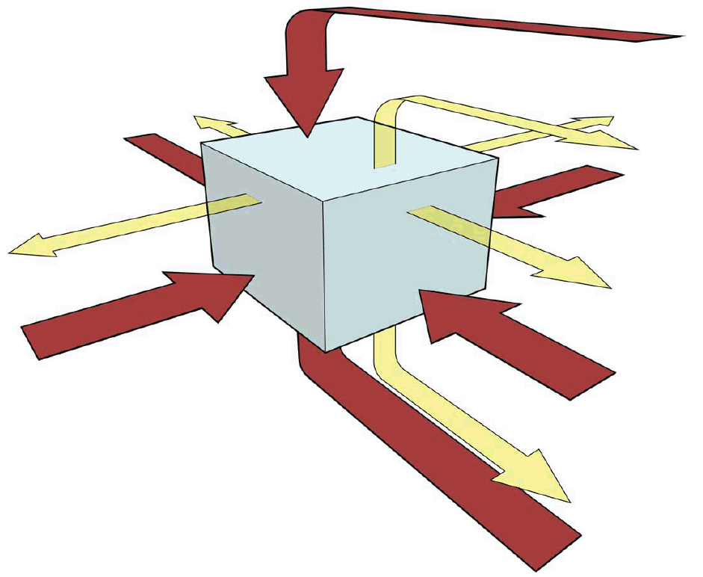
            - Example Using a 2x1 Table to Align Graphics
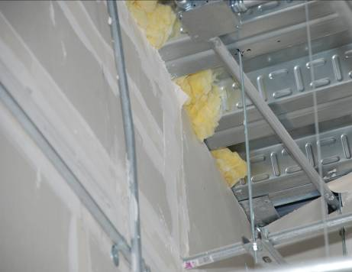 | 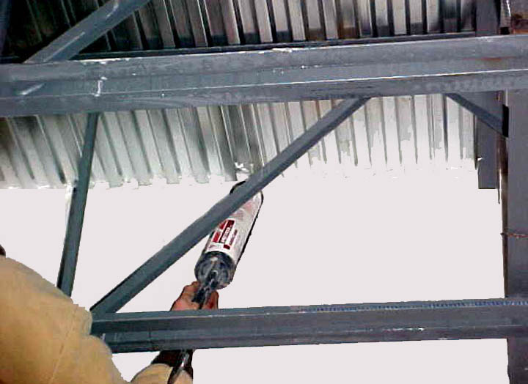
  - TABLES.
Style for table titles is UFCtable. Style for tables is UFCtext . Per UFC 1-300-01, Font size may be reduced to a minimum 8-point to enhance the presentation of data within a table. See Table 2-1. Again, utilize the cross-reference capability in Word to link the reference to the appropriate Table similar to Figures.

              - Example Table
Type | Description | Plan View
Type I | Narrow, symmetric illuminance pattern. | 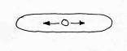
Type II | Slightly wider illuminance pattern than Type I. | 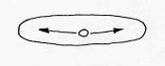
Type III | Wide illuminance pattern. | 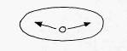
Type IV | Widest illuminance pattern. | 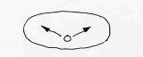
Type V | Symmetrical circular illuminance pattern.
Type VS | Symmetrical, nearly square illuminance pattern. | 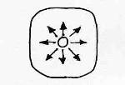

  - EQUATIONS.
Style for Equation titles is UFCEquation. Use MS Word® built-in support for writing and editing equations. Per UFC 1-300-01, Font size may be reduced to a minimum 8-point to enhance the presentation of data within a table. See Equation 2-1.
                - Steel Thickness to Prevent Projectile Perforation
Where:
v = impact velocity (m/s)
D = projectile diameter (mm)
T_{S} = thickness of steel plate to prevent perforation (mm)
θ = angle of obliquity (degrees)
m = mass of projectile (kg)
BHN = Brinnell Hardness Number
  - BULLETED LISTS.
Per UFC 1-300-01, use alphabetical or numerical bullets when the list must be followed in order and use symbol bullets when no order is required.
          - Use bulleted lists when the order does not matter.
          - Style for bulleted list is UFCbullet.

- Use lettered when the list must be followed in order.
- Style for lettered list is UFCletter bullet

- Numbered list may also be used when the list is must be followed in order.
- Style for lettered list is UFCnumber bullet.
  - COMMENTARY.
When commentary is provided, the following is an example of the formatting for commentary. This example uses a highlighted (25% grey) text box. Refer to UFC 1-300-01 for example paragraph associated with commentary.
[C] 2-1613.1 [Supplement] Scope
Although Chapter 14 of ASCE 7-10 is not adopted by the 2015 IBC, occasional references to ASCE 7-10 Chapter 14 sections are made in this UFC.
  - FUNCTIONAL DATA SHEET.
When required, Figure 2-3 is an example of a Functional Data Sheet. Refer to UFC 1-300-01 for example paragraph associated with Functional Data Sheets.

            - Example Functional Data Sheet
Description/Usage
Ceiling Height
Windows
Doors
Interior Construction / Built-in Equipment
Finishes | Walls
 | Floor
 | Base
 | Ceiling
Plumbing
HVAC
Fire Protection and Life Safety
Power
Lighting
Telecommunications | Telephone
 | Data
 | CATV
Security | IDS
 | ACS
 | VIDEO
Acoustics
Furnishings and Equipment
Special Requirements
Adjacencies / Location within Facility
 | For Use during project execution by appropriate Service
Occupancy | Staff
 | Other
Min. net Ft² (m²)

Use blank pages to ensure new chapters start on side one of a two sided printout.

Section breaks are utilized so the vertical alignment of this page can be set to be centered in page setup. To accomplish this, go to Page Setup > Layout tab > under Page > Vertical alignment > choose Center. Make sure the following page has the Vertical alignment set back to Top.

This Page Intentionally Left Blank

- DESIGN
  - MAJOR PARAGRAPH TITLE.
Style for Major Paragraph Titles is UFCpara1. Style for paragraph text is UFCtext.
    - First level subparagraph title.
Style for First level subparagraph titles is UFCpara2. Style for paragraph text is UFCtext.
      - Second level subparagraph title.
Style for second level subparagraph titles; if used, is UFCpara3. Style for paragraph text is UFCtext.
        - Third level subparagraph title.
Style for Third level subparagraph titles; if used, is UFCpara4. Style for paragraph text is UFCtext.
  - MAJOR PARAGRAPH TITLE.
    - First level subparagraph title.
      - Second level subparagraph title.
        - Third level subparagraph title.
  - MAJOR PARAGRAPH TITLE.
  - MAJOR PARAGRAPH TITLE.
    - First level subparagraph title.
    - First level subparagraph title.

This Page Intentionally Left Blank

- TITLE
  - MAJOR PARAGRAPH TITLE.
Style for Major Paragraph Titles is UFCpara1. Style for paragraph text is UFCtext.
Any additional chapters should be created utilizing the same Styles and paragraph numbering as previous chapters.

This Page Intentionally Left Blank

- BEST PRACTICES
Appendix Title is UFCAppendix.
Best Practices; if required, starts with Appendix A. This information is considered to be guidance and not requirements. The main purpose is to communicate proven system/facility solutions and lessons learned and may not be the only solution to meet UFC requirements. It is not intended to be a textbook or to repeat information from industry standards and non-government references. The Best Practices Appendices are not intended to parallel the chapter organization and numbering of the technical requirements section of the main text.
  - MAJOR PARAGRAPH TITLE.
Style for Major Paragraph Titles is UFCAppendixpara1. Style for paragraph text is UFCtext.
    - First level subparagraph title.
Style for First level subparagraph titles is UFCAppendixpara2. Style for paragraph text is UFCtext.
      - Second level subparagraph title.
Style for second level subparagraph titles; if used, is UFCAppendixpara3. Style for paragraph text is UFCtext.
        - Third level subparagraph title
Style for Third level subparagraph titles; if used, is UFCAppendixpara4. Style for paragraph text is UFCtext.
  - MAJOR PARAGRAPH TITLE.
Style for Major Paragraph Titles is UFCAppendixpara1. Style for paragraph text is UFCtext.
    - First level subparagraph title.
Style for First level subparagraph titles is UFCAppendixpara2. Style for paragraph text is UFCtext.
      - Second level subparagraph title.
Style for second level subparagraph titles; if used, is UFCAppendixpara3. Style for paragraph text is UFCtext.
        - Third level subparagraph title
Style for Third level subparagraph titles; if used, is UFCAppendixpara4. Style for paragraph text is UFCtext.
  - MAJOR PARAGRAPH TITLE.
Style for Major Paragraph Titles is UFCAppendixpara1. Style for paragraph text is UFCtext.
  - MAJOR PARAGRAPH TITLE.
Style for Major Paragraph Titles is UFCAppendixpara1. Style for paragraph text is UFCtext.
  - MAJOR PARAGRAPH TITLE.
Style for Major Paragraph Titles is UFCAppendixpara1. Style for paragraph text is UFCtext.

If the definition of a term has a source, provide citation using the “Insert Citation” function.
- GLOSSARY
  - ACRONYMS.
AFCEC Air Force Civil Engineer Center
BIA Bilateral Infrastructure Agreement
DoD Department of Defense
HQUSACE Headquarters, U.S. Army Corps of Engineers
HNFA Host Nation Funded Construction Agreements
NAVFAC Naval Facilities Engineering Systems Command
SOFA Status of Forces Agreements
UFC Unified Facilities Criteria
U.S. United States

  - DEFINITION OF TERMS.
UFCAppendFigure: Custom Microsoft Word Style used for the titles of Figures located in an appendix.
UFCAppendix: Custom Microsoft Word Style used for Appendix titles.
UFCAppendixpara1: Custom Microsoft Word Style used for Major Paragraph Titles in appendixes
UFCAppendixpara2: Custom Microsoft Word Style used for First level subparagraph titles in appendixes
UFCAppendixpara3: Custom Microsoft Word Style used for Second level subparagraph titles in appendixes
UFCAppendixpara4: Custom Microsoft Word Style used for Third level subparagraph titles in appendixes
UFCAppendTable: Custom Microsoft Word Style used for the titles of Tables located in an appendix.
UFCbullet: Custom Microsoft Word Style used for bulleted lists
UFCchapter: Custom Microsoft Word Style used for Chapter titles
UFCfigure: Custom Microsoft Word Style used for the titles of Figures
UFCpara1: Custom Microsoft Word Style used for Major Paragraph Titles
UFCpara2: Custom Microsoft Word Style used for First level subparagraph titles
UFCpara3: Custom Microsoft Word Style used for Second level subparagraph titles
UFCpara4: Custom Microsoft Word Style used for Third level subparagraph titles
UFCreference: Custom Microsoft Word Style used for Reference Text
UFCreferenceOrg: Custom Microsoft Word Style used for Reference Organization
UFCtable: Custom Microsoft Word Style used for the titles of Tables
UFCtext: Custom Microsoft Word Style for paragraph text

- REFERENCES
Style for Appendix Title is UFCAppendix.
Style for reference organization is UFCreferenceOrg. Style for Reference is UFC reference with reference titles in italics. The following are provided as an example organized by reference type. References listed here must be referenced in the UFC.
UNDERWRITER’S LABORATORY
UL 681, Installation and Classification of Burglar and Holdup Alarm Systems for alarm system installation
UL 2050, National Industrial Security Systems UL 2050 materials are restricted and only distributed to those demonstrating relevant national industrial security involvement.
UNIFIED FACILITIES CRITERIA
https://www.wbdg.org/ffc/dod/unified-facilities-criteria-ufc
UFC 1-200-01, DoD Building Code
UFC 4-010-01, DoD Minimum Antiterrorism Standards for Buildings
UFC 4-020-01, DoD Security Engineering Facilities Planning Manual
UFC 4-020-02, DoD Security Engineering Facilities Design Manual, currently in Draft and unavailable
UFC 4-021-02, Electronic Security Systems

Document: UFC X-XXX-XX, Title
Reissues and Cancels: List applicable documents that are being reissued, canceled or None
Working Group:
Date:
Impact.
The following direct impacts will result from the [publication][update] of this UFC. Describe both positive and negative impacts. If there are no impacts, state “No impact”. Topics to include:
          - Initial cost
          - Life cycle cost
          - Safety
          - Efficiency
          - Security
Unification Issues.
List all unification issues in the order they appear in the UFC.
- Identify paragraph number.
- Identify the Service(s) the unification issue applies to.
- Provide justification for each issue. Cite any Service specific policy, regulation, mission or operational justifications why the criterion cannot be unified.

