U.S. AIR FORCE
BUILDING INFORMATION MODELING PROJECT EXECUTION PLAN
(PxP)
Version 2.1

FOR:
AIR FORCE CIVIL ENGINEER CENTER
ON
[PROJECT TITLE]
[PROJECT LOCATION]
[USAF PROJECT NUMBER(S)]

DEVELOPED BY
[AUTHOR COMPANY]

DATE[XX/XXX/XX]
INSTRUCTIONS AND REFERENCE INFORMATION
This template is a tool that is provided to assist in the development of a BIM Project Execution Plan (PxP) as required per Awarded Contract or Proposal Submission Requirements. It was adapted from the National BIM Standard (NBIMS) – US Version 2, Section 5.4 BIM Project Execution Plan Content – Version 2.1, BIM Project Execution Plan Template. For Reference Information only on content in this template, such as BIM Use definitions please see the NBIMS Chapter 5 Practice Documents and related Section 5.3 BIM Project Execution Planning Guide at www.nationalbimstandard.org.
The U.S. Air Force is an Alliance Sponsor Member of the National Institute of Building Sciences (NIBS) http://www.nibs.org/?page=organizations. NBIMS is a product of the Building SMART Alliance which serves as a Council of NIBS http://www.nibs.org/?page=bsa.
Instructions and examples to assist with the completion of this guide are currently in red. The text can and should be modified to suit the needs of the organization filling out the template. If modified, the format of the text should be changed to match the rest of the document. This can be completed, in most cases, by selecting the normal style in the template styles.

Questions pertaining to an individual solicitation shall be directed to the advertising district's contracting specialist for that solicitation.

Questions pertaining to this template should be directed to AFCEC Workflow (afcec.cf.workflow@us.af.mil), Paul Womble (paul.womble@us.af.mil), or Jose Castro-Rodriguez (jose.castro-rodriguez@us.af.mil).

TABLE OF CONTENTS
SECTION A: PROJECT INFORMATION 1
SECTION B: KEY PROJECT CONTACTS 3
SECTION C: PROJECT GOALS / BIM OBJECTIVES 4
SECTION D: ORGANIZATIONAL ROLES / STAFFING 7
SECTION E: BIM PROCESS DESIGN 8
SECTION F: BIM INFORMATION EXCHANGE WORKSHEET 10
SECTION G: MINIMUM MODELING AND DATA REQUIREMENTS 11
SECTION H: COLLABORATION PROCEDURES 12
SECTION I: QUALITY CONTROL 13
SECTION J: TECHNOLOGICAL INFRASTRUCTURE NEEDS 14
SECTION K: MODEL ORGANIZATION 16
SECTION L: PROJECT DELIVERABLES 17
SECTION M: ATTACHMENTS 18
SECTION N: REFERENCES 19

SECTION A: PROJECT INFORMATION
Unless otherwise noted, text in black is a contract requirement and shall not be modified. Instructions and examples to assist with the completion of the PxP are in red. Red text shall be deleted from the final PxP. Additional text may be added to suit the needs of the USAF proponent. If modified, the format of the text should be changed to match the rest of the document. The PxP is primarily written from the point of view that the project will be executed as a Design-Build (D-B) contract since that is the USAF’s preferred method of execution. The document should be modified for Design-Bid-Build (D-B-B) execution. Notes in red text discussing variations to the PxP for D-B-B execution are provided where appropriate. The D-B contractor or the D-B-B Architect-Engineer (A-E) shall complete the PxP, and submit it for Government review and acceptance. D-B projects should include a Section in the RFP that discusses the requirements for the BIM and require the completion of the PxP by the D-B contractor as a submittal. For D-B-B projects, the A-E shall complete the PxP. BIM requirements for the Construction Contractor should be included in the project Specifications, and include the PxP as an attachment. The D-B-B Construction Contractor should complete a PxP for the “as-built” Record BIM. One PxP should be completed for each contract describing the means and methods to be employed for that contract scope. As a living document, it shall be updated whenever implementation details change for Government review and acceptance. At final handover, the PxP shall reflect the delivered end products and provided as reference for future consumers of the BIM.
It is preferable to the Air Force to have bidding firms accomplish a draft implementation plan to be used as a discriminator for possible award to the firms who propose maximum BIM use throughout the facility lifecycle. Whether the BIM Project Execution Plan is accomplished before or after award, the plan shall include using the BIM data for the minimum requirements delineated in the USAF MINIMUM BIM REQUIREMENTS.
To successfully execute Building Information Modeling (BIM) on a project, [AUTHOR COMPANY] has developed this detailed BIM Project Execution Plan. The BIM Project Execution Plan defines uses for BIM on the project (e.g. design authoring, design reviews, 3D coordination, and record modeling), along with a detailed process for executing BIM on this project.
U.S. AIR FORCE BIM MISSION STATEMENT
U.S. Air Force Strategic BIM Goals and Objectives are aligned to directly support the Air Force Civil Engineer (CE) mission identified in the 2011 CE Strategic Plan: “…provide, operate, maintain and protect sustainable installations as weapon-system platforms through engineering and emergency response services across the full mission spectrum.”

The Civil Engineer Strategic Plan identifies three Goals as the foundation of the CE Strategy:
- Build Ready Engineers,
- Build Great Leaders, and
- Build Sustainable Installations.

The project goals and BIM Uses identified in Section C have been developed to support the CE Strategic Plan. Except for some minor modifications in Section C, the BIM Uses were previously developed for the National BIM Standard. The identified BIM Uses are selected to meet the USAF goals that were developed to support the CE Strategic Plan

This section defines basic project reference information and will be conveyed to the to the AGENT PM from the USAF PM via Design Instruction..
- FACILITY INTENDED END USER: E.G. US AIR FORCE, ETC.
- PROJECT NAME: E.G. DORMITORY; MUST BE THE SAME AS SHOWN ON THE DD FORM 1391
- PROJECT LOCATION: E.G. FAIRCHILD AFB, WA
- CONTRACT TYPE: E.G. DESIGN-BUILD
- FACILITY TYPE: LIST ALL FACILITIES IN THE CONTRACT; MUST BE THE SAME AS SHOWN ON THE DD FORM 1391
- BRIEF PROJECT DESCRIPTION: NUMBER OF FACILITIES, GENERAL SIZE, ETC
- ADDITIONAL PROJECT INFORMATION: UNIQUE BIM PROJECT CHARACTERISTICS AND REQUIREMENTS
- AGENT: E.G. USACE, NAVFAC, AFCEC
- PROJECT NUMBERS: E.G. AF PROJECT NUMBER AS SHOWN ON THE DD FORM 1391
PROJECT INFORMATION | NUMBER
AGENT CONTRACT NUMBER: | E.G. W9126G-08-D-0000
TASK ORDER: | E.G. 0001
AGENT PROJECT NUMBER: | E.G. PN055198
CONTRACTOR INFORMATION | NUMBER
AF PROJECT NUMBER(S): | E.G.SXHT123456
SECTION B: KEY PROJECT CONTACTS
The following is a list of the lead Designer of Record and BIM contacts for each organization on the project. Additional contacts can be included later in the document.
ROLE | ORGANIZATION | NAME | EMAIL | TIME ZONE | PHONE
Project Manager  (DM/CM) | AFCEC | John Doe
Project Manager  (DA/CA) | AGENT
Agent BIM Manager | AGENT
Installation Project Manager
Installation BCE POC
Project Manager(s) | Company
BIM Manager(s) | Companies
Architecture Lead | Company
Interior Design
Structural Lead | Company
Furnishings Lead | Company
Equipment Lead
Landscape Architect Lead
Civil Lead
Fire Protection Lead
Mechanical Lead
Plumbing Lead
Electrical Lead
Telecom Lead
Other Project Roles
SECTION C: PROJECT GOALS / BIM OBJECTIVES
Describe how the BIM Model and Facility Data are utilized to maximize project value (e.g. design alternatives, life-cycle analysis, energy analysis, sustainability analysis scheduling, estimating, material selection, pre-fabrication opportunities, site placement, etc.)

Reference www.nationalbimstandard.org for the BIM Goal & Use Analysis Worksheet.
- MAJOR BIM GOALS / OBJECTIVES:
State the BIM Goals / Objectives. The USAF level goals are described below and should not be removed from the PxP. Additional project level BIM goals may be added.
BIM GOAL | DESCRIPTION
Integrate project-level BIMs with current and projected software tools. | Integrate BIM data with AF Facility Management and GeoBase geospatial tools. The current AF strategy for accomplishing this goal is to provide Construction Operations Building Information Exchange (COBie) data to populate Tririga and BUILDER databases and to geo-locate BIM models
Support the Total Force Civil Engineer team by providing NexGen IT integrated software tools | Project-level BIMs must utilize and integrate with approved AF software tools
Support sustainable installations and asset management | Provide BIM and software tools to support lifecycle-based program management aligned with other federal government entities and universally adopted standards.  Implement BIM-based planning, design and construction and by delivering a BIM model that integrate with approved facility management tools/software  Apply BIM-enabled FM systems to optimize management of RP resources.  Implement BIM-based energy modeling during Programming/Requirements Development and Design phases and implement BIM-based EMCS sensor planning/monitoring
Eliminate conflicts | Clash Detection software is used during the design and construction phases to identify conflicts by comparing 3D models of building systems. The goal of clash detection is to eliminate the major system conflicts prior to installation. The information model is then used to create detailed control points to aid in assembly layout. An example of this is layout of foundations using a total station with points preloaded and/or using GPS coordinates to determine if proper excavation depth is reached.
Accurate 3D Record Model for FM Team | The Record Model shall, at a minimum, contain the culmination of all the BIM modeling throughout the project, including linking Operation, Maintenance, and Asset data to the as-built model (created from the Design, Construction, 4D Coordination Models, and Subcontractor Fabrication Models) to deliver an accurate Record Model to the Air Force asset manager. Additional information including equipment (computer racks, UPS, material handling; where applicable) and space planning system shall be included to ensure they interface properly with building systems. For D-B-B projects, the A-E will develop the Design Model and Specifications for the Construction Contractor for producing the Record Model

- BIM USES:
The BIM Uses currently highlighted/shaded and checked with an (X) are required by USAF BIM Requirements. Contractor to identify with a (C) additional BIM Uses for the project selected as Contractor Electives. Reference BIM Project Execution Planning Guide at www.nationalbimstandard.org for BIM Use descriptions. Include additional BIM Uses as applicable in empty cells of Design and Construct columns. Do not complete Plan and Operate Columns.
 | PLAN (NIC) |  | DESIGN |  | CONSTRUCT |  | OPERATE (NIC)
 | PROGRAMMING | X | DESIGN AUTHORING |  | SITE UTILIZATION PLANNING |  | BUILDING SYSTEM ANALYSIS
 | SITE ANALYSIS | X | DESIGN REVIEWS |  | CONSTRUCTION SYSTEM DESIGN |  | ASSET MANAGEMENT
 |  | X | 3D COORDINATION -INTERFERENCE MANAGEMENT | X | 3D COORDINATION -INTERFERENCE MANAGEMENT |  | SPACE MANAGEMENT / TRACKING
 |  |  | ENGINEERING ANALYSIS - STRUCTURAL |  | DIGITAL FABRICATION |  | DISASTER PLANNING
 |  |  | ENGINEERING ANALYSIS - LIGHTING | X | 3D CONTROL AND PLANNING / DIGITAL LAYOUT
 |  |  | ENGINEERING ANALYSIS - ENERGY | X | RECORD MODELING |  | RECORD MODELING
 |  |  | PROGRAM VALIDATION |  | FIELD / MATERIAL TRACKING
 |  |  | ENGINEERING ANALYSIS - MECHANICAL
 |  | X | 3D CONTROL AND PLANNING (DIGITAL LAYOUT) - GEOLOCATING THE PROJECT
 |  |  | SUSTAINABILITY (LEED) EVALUATION
 |  |  | ENGINEERING ANALYSIS – OTHER (PER CONTRACT REQUIREMENTS)
 |  |  | CODE VALIDATION
 | PHASE PLANNING (4D) |  | PRELIMINARY CONSTRUCTION SCHEDULING (4D) |  | CONSTRUCTION SCHEDULING (4D) |  | BUILDING (PREVENTIVE) MAINTENANCE SCHEDULING (4D)
 | COST ESTIMATION (5D) | X | COST ESTIMATION (5D) |  | COST ESTIMATION (5D) |  | COST ESTIMATION (5D)
 | EXISTING CONDITIONS MODELING |  | EXISTING CONDITIONS MODELING |  | EXISTING CONDITIONS MODELING |  | EXISTING CONDITIONS MODELING
 | CONSTRUCTION OPERATIONS BUILDING INFORMATION EXCHANGE (COBie) | X | CONSTRUCTION OPERATIONS BUILDING INFORMATION EXCHANGE (COBie) | X | CONSTRUCTION OPERATIONS BUILDING INFORMATION EXCHANGE (COBie)  BUILDER and Omniclass as required |  | CONSTRUCTION OPERATIONS BUILDING INFORMATION EXCHANGE (COBie)  BUILDER and Omniclass as required

BIM USE: CONSTRUCTION OPERATIONS BUILDING INFORMATION EXCHANGE
Description:
This is an interim process to achieve the Asset Management BIM Use by populating Record Model attributes and COBie spreadsheets to provide facility information to the USAF’s NextGen IT Facilities Management system. Facility data shall include all information associated with the Design and Constructions worksheets as well as the Spares worksheet from the Operations and Maintenance worksheets.

Potential Value:
- Store operations, maintenance owner user manuals, and equipment specifications for faster access.
- Maintain up-to-date facility and equipment data including but not limited to maintenance schedules, warranties, cost data, upgrades, replacements, damages/deterioration, maintenance records, manufacturer's data, and equipment functionality

Resources Required:
- Record Model
- COBie database
COBie Data Formats: The USAF’s Facility Management system is transitioning under the NextGen IT initiative to TRIRIGA and BUILDER. TRIRIGA is able to import COBie standard Omniclass formatted data via XML spreadsheets while BUILDER utilizes data formatted in Uniformat II. Facility asset data that will be maintained in BUILDER must first be uploaded into the BUILDER Remote Entry Database (BRED). Refer to the BRED Data Dictionary for data format requirements.

Team Competencies Required:
- Pre-design knowledge of which assets are worth tracking, whether the building is dynamic vs. static, and the end needs of the building to satisfy the end user
- Knowledge of the asset management system

Selected Resources:
- NIST (2007) General Buildings Information Handover Guide: Principles, Methodology, and Case Studies
- BUILDER Remote Entry Database (BRED) Data Dictionary

SECTION D: ORGANIZATIONAL ROLES / STAFFING
For each BIM Use required and Contractor selected, identify the team within the organization (or organizations) who will staff and perform that Use. Staff members may fill multiple project roles.

DESIGN PHASE BIM USE | ORGANIZATION | LOCATION(S) | LEAD CONTACT
DESIGN AUTHORING | Contractor A
PROGRESS REVIEWS | B
DESIGN 3D COORDINATION | C
3D CONTROL & PLANNING (GEOLOCATING THE PROJECT) | D
COST ESTIMATION (5D) | E
COBIE | F

CONSTRUCTION PHASE BIM USE | ORGANIZATION | LOCATION(S) | LEAD CONTACT
CONSTRUCTION 3D COORDINATION | G
3D CONTROL & PLANNING | H
RECORD MODELING | I
COBIE | J

List enhancements from minimum BIM Uses as selected in Section C.2. Note: Enhancements must exceed minimum Contract requirements BIM Uses. (i.e. performing structural analyses on specific areas versus whole facility, performing cost / quantity take- off on specific floors versus whole facility, etc,) All documents and files related to the BIM uses shall be provided to the government as a submittal.

SELECTED BIM USE ENHANCEMENT | DESCRIPTION / ADDED VALUE

SECTION E: BIM PROCESS DESIGN
Provide an Overview Process Map for all BIM Uses (Level 1). Provide Detailed Process Maps for each REQUIRED (marked with X) and Contractor-Elected (marked with C) BIM Use in Section D (Level 2). Sample Process Maps may be downloaded from www.nationalbimstandard.org for your use. (Please note that these are sample maps and should be modified based on project specific information and requirements and contractor internal procedures and processes). Please reference the BIM Project Execution Planning Guide found at www.nationalbimstandard.org.

LEVEL ONE PROCESS OVERVIEW MAP: ATTACHMENT 1
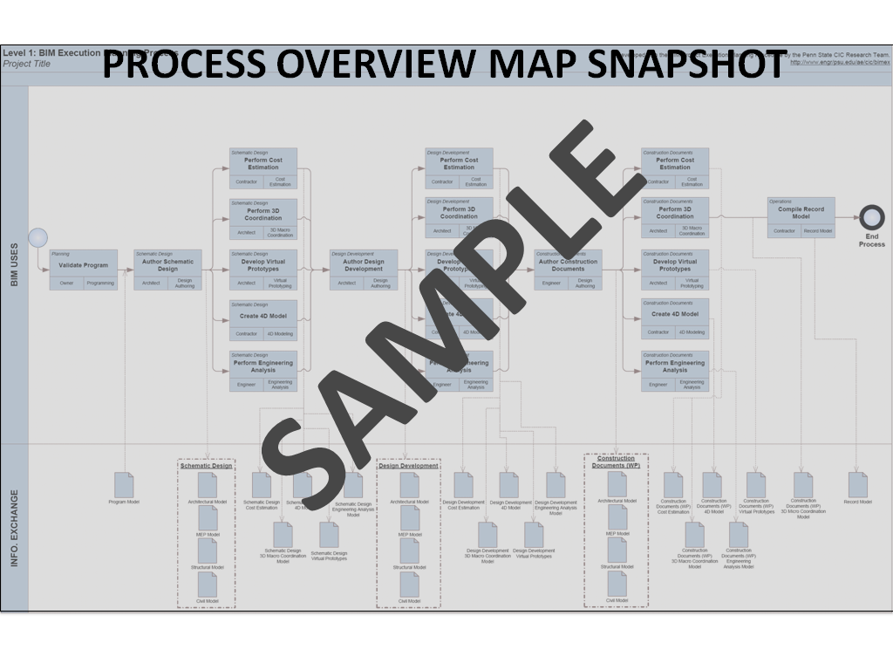
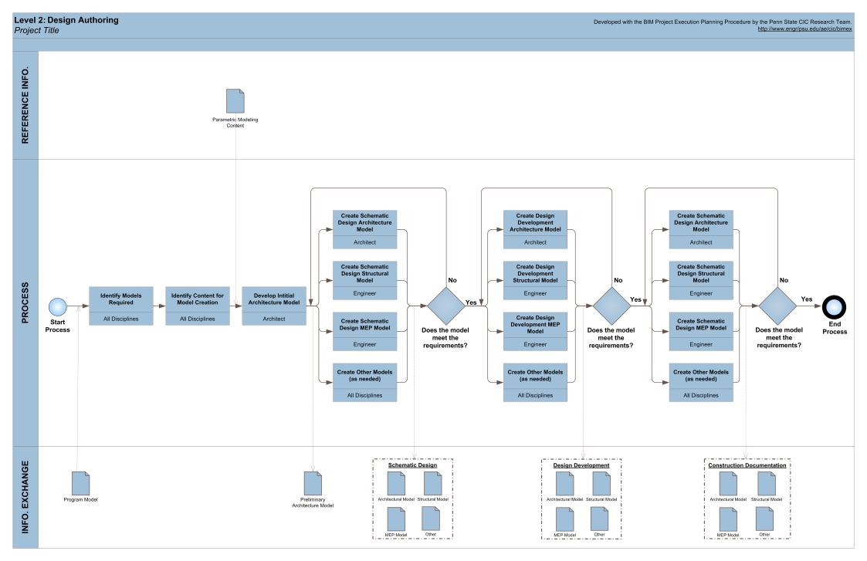
LEVEL TWO DETAILED PROCESS MAP: ATTACHMENT 2
SECTION F: BIM INFORMATION EXCHANGE WORKSHEET
Model elements by discipline, level of detail, and any specific attributes important to the project are documented using information exchange worksheet. Reference Chapter Four: Defining the Requirements for Information Exchanges in the BIM Project Execution Planning Guide for details on completing this template. Submittal of these worksheets to the AGENT IS CURRENTLY NOT REQUIRED, however, it is suggested that the Contractor review and apply these worksheets with their Project Team.
- LIST OF INFORMATION EXCHANGE WORKSHEET(S): ATTACHMENT 3
(The following are examples. Modify for specific project. Some Information Exchanges may need to be removed, while some information exchanges may need to be added.)
- Existing Conditions Modeling
- Programming
- Site Analysis
- Cost Estimation
- 4D Modeling
- Design / Progress Reviews
- Design Authoring
- Energy Analysis
- Structural Analysis
- Lighting Analysis
- 3D Coordination
- Site Utilization Planning
- 3D Control and Planning
- Record Modeling
- Maintenance Scheduling
- Building System Analysis
- Construction Operations Building Information Exchange (COBie)
- [Delete unused and add additional information exchange worksheets from list]
SECTION G: MINIMUM MODELING AND DATA REQUIREMENTS

MINIMUM MODELING MATRIX (M3): ATTACHMENT 4
Provide an M3 with Column ‘F’ filled to reflect the actual scope of work for the facility and site. Use the Minimum Modeling Matrix (M3) Template located at https://cadbim.usace.army.mil and submit as part of the PxP in Section M, Attachment 4.

Column ‘F’ of the M3 shall represent the actual scope of work and should not be filled out according to Contractor preference. The Contractor shall identify items in Column ‘F’ which are NOT included in the project scope for the facility and site.

ELECTIVE MODELING ENHANCEMENTS
List enhancements from minimum modeling requirements as specified in Contract. Note: Enhancements must exceed minimum Contract requirements of the M3. (i.e. using newer release of AEC CAD Standard or IFC Version, modeling all plumbing/HVAC system and not only 1.5” and above,)
ENHANCEMENT | JUSTIFICATION
SECTION H: COLLABORATION PROCEDURES
- COLLABORATION STRATEGY:
Describe how the project team will collaborate in development and execution of modeling for the project. Include items such as electronic communication requirements and procedures, document management, transfer, and updating, and record storage, etc.
- COLLABORATION ACTIVITIES:
The following activities are required. Add any additional meeting activities as determined by the Project Team.
ACTIVITY TYPE | REQUIRED PER CONTRACT | PROJECT STAGE | FREQUENCY | PARTICIPANTS | LOCATION
BIM REQUIREMENTS KICK-OFF | YES | D-B DESIGN KICK-OFF | ONCE | w/ USACE DISTRICT BIM MANAGER AND END USER REPRESENTATIVE | WEB MEETING OR AGREED LOCATION
BIM EXECUTION PLAN DEMONSTRATION | YES | D-B DESIGN KICK-OFF | ONCE | w/ USACE DISTRICT BIM MANAGER AND END USER REPRESENTATIVE | WEB MEETING OR AGREED LOCATION
DESIGN COORDINATION | YES | D-B DESIGN | WEEKLY | A-E | WEB MEETING OR AGREED LOCATION
OVER-THE-SHOULDER PROGRESS REVIEWS | YES | D-B DESIGN | MONTHLY | w/ AGENT | WEB MEETING OR AGREED LOCATION
DESIGN REVIEW CONFERENCE | YES | D-B DESIGN | EACH REVIEW CONFERENCE | w/ AGENT AND END USER REPRESENTATIVE | ON SITE
ANY OTHER BIM ACTIVITY THAT OCCURS WITH MULTIPLE PARTIES

SECTION I: QUALITY CONTROL
- OVERALL STRATEGY FOR QUALITY CONTROL
Describe the strategy to control the quality of the model.
- QUALITY CONTROL CHECKS
The following checks shall be performed to assure quality.
CHECKS | DEFINITION | RESPONSIBLE PARTY | SOFTWARE PROGRAM(S) | FREQUENCY
VISUAL CHECK | Ensure there are no unintended model components and the design intent has been followed | Name here | Software here | AT EVERY SUBMITTAL
INTERFERENCE CHECK | Detect problems in the model where two building components are clashing including soft and hard | Name here | Software here | AT EVERY SUBMITTAL
STANDARDS CHECK | Ensure that the BIM and AEC CADD Standard have been followed (fonts, dimensions, line styles, levels/layers, etc) | Name here | Software here | AT EVERY SUBMITTAL
MODEL INTEGRITY CHECKS | Describe the QC validation process used to ensure that the Project Facility Data set has no undefined, incorrectly defined or duplicated elements and the reporting process on non-compliant elements and corrective action plans | Name here | Software here | AT EVERY SUBMITTAL
VERSION UPDATING  CHECK | Ensuring that all users are using the agreed upon version of the software and the method by which changing software version is completed | Name here | Software here | AT EVERY SUBMITTAL
REVISION AUTHORITY CHECK | Describe the method by which all users will be given access and extent of revision authority to versions of the model as updated. | Name here | Software here | AT EVERY SUBMITTAL
SECTION J: TECHNOLOGICAL INFRASTRUCTURE NEEDS
- SOFTWARE:

All submitted BIM Models and associated Facility Data shall be fully compatible with Autodesk Revit file format and the Autodesk Revit BIM Template for U.S. Air Force Projects. List software used to deliver BIM. Remove BIM Use and software that is not applicable. Describe procedure for changing the software version during project execution.
BIM USE | USER | SOFTWARE | VERSION
DESIGN AUTHORING | ARCHITECTURAL | XYZ DESIGN APPLICATION
DESIGN AUTHORING | STRUCTURAL | XYZ DESIGN APPLICATION
DESIGN AUTHORING | MECHANICAL | XYZ DESIGN APPLICATION
DESIGN AUTHORING | ELECTRICAL/TELECOM | XYZ DESIGN APPLICATION
DESIGN AUTHORING | PLUMBING | XYZ DESIGN APPLICATION
DESIGN AUTHORING | FIRE PROTECTION | XYZ DESIGN APPLICATION
DESIGN AUTHORING | CIVIL | XYZ DESIGN APPLICATION
DESIGN AUTHORING | ANTI-TERRORISM  FORCE PROTECTION | XYZ DESIGN APPLICATION
DESIGN AUTHORING | INTERIOR | XYZ DESIGN APPLICATION
SCHEDULING (4D) |  | SCHEDULING (4D) MODELING SOFTWARE
COST ESTIMATION (5D) |  | COST ESTIMATION (5D) SOFTWARE
EXISTING CONDITIONS MODELING |  | EXISTING CONDITIONS MODELING SOFTWARE
SITE UTILIZATION PLANNING |  | SITE UTILIZATION PLANNING SOFTWARE
CONSTRUCTION SYSTEM DESIGN |  | CONSTRUCTION SYSTEM DESIGN SOFTWARE
DIGITAL FABRICATION |  | DIGITAL FABRICATION SOFTWARE
3D CONTROL AND PLANNING |  | 3D CONTROL AND PLANNING SOFTWARE
3D COORDINATION |  | 3D COORDINATION SOFTWARE
DESIGN REVIEWS |  | DESIGN REVIEWS SOFTWARE
STRUCTURAL ANALYSIS |  | STRUCTURAL ANALYSIS SOFTWARE
LIGHTING ANALYSIS |  | LIGHTING ANALYSIS SOFTWARE
ENERGY ANALYSIS |  | ENERGY ANALYSIS SOFTWARE
SUSTAINABILITY EVALUATION |  | SUSTAINABILITY EVALUATION SOFTWARE
CODE VALIDATION |  | CODE VALIDATION
PROGRAMMING |  | PROGRAMMING
SITE ANALYSIS |  | SITE ANALYSIS
COBIE

- BIM and CAD Standards:
Identify items such as the BIM and CAD graphical, naming, and protocol standards, BIM Workspace version, and the version of IFC, etc.

The submitted BIM Model – The BIM shall be in a native file format with linked performance based specifications (via e-SPECS for Revit with SpecsIntact integration), interactive for the user, and the model shall be provided in the AF standard platform (Autodesk Revit) and interoperable file format like the Industry Foundation Class (IFC).

IFC Coordination View – The Contractor’s selected BIM application(s) and software(s) must be certified in the IFC Coordination View (2x3 or newer. See www.iai-tech.org). Submit any deviations from or additions to the IFC property sets for any new spaces, systems, and equipment for Government approval.

Autodesk Revit BIM Template for US Air Force projects Version 2010 http://www.wbdg.org/references/afbim_tools.php

STANDARD | VERSION
BIM Workspace: | Insert BIM software and version here
CAD Standard: | AEC CAD Standard 5.0
Industry Foundation Class: | IFC2x3
COBie: | COBie 2.24
SECTION K: MODEL ORGANIZATION
- FILE NAMING STANDARD:
List examples of file names by discipline
- MODEL STRUCTURE:
Describe and diagram how the Model is divided up. For example, by building, by floors, by zone, by areas, and/or discipline
- MEASUREMENT AND COORDINATE SYSTEMS:
Describe the measurement system (Imperial or Metric) and coordinate system (geo-reference) used

SECTION L: PROJECT DELIVERABLES
In this section, list the BIM deliverables for the project and the format in which the information will be delivered.

During the Submittal stages, the Contractor shall deliver the construction schedule with information derived from the Model.
Periodic quality control meetings or construction progress review meetings shall include quality control reviews on the implementation and use of the Model for project scheduling.

BIM SUBMITTAL ITEM | STAGE | FORMAT | NOTES
The Model, Facility/Site Data, Workspace in the native format and DWF format | ALL
CAD files in the native format and DWF format | ALL
COBie data extract in Excel format
Interactive Review Format (Bentley Navigator, Autodesk Navisworks, Adobe 3D PDF 7.0 (or later), Google Earth KMZ, etc) | ALL
Revit Compare Tool report | CONSTRUCTION
QA/QC reports – Model Standards Check Report | ALL
QA/QC reports – CAD Standards Check Report | ALL
QA/QC reports – Model Integrity Validation | ALL
QA/QC reports - Visual Check Report | ALL
QA/QC reports - Interference Management Checks | ALL
IFC Coordination View | ALL
QA/QC reports - Other Design QA/QC Reports | ALL
List of all submitted files (Excel spreadsheet preferred) | ALL
Other BIM Deliverables | ALL

SECTION M: ATTACHMENTS
Contractor/A-E shall complete and attached the required documents listed below to this Section of the PxP.
- LEVEL ONE PROCESS OVERVIEW MAP FROM SECTION E
- LEVEL TWO DETAILED BIM USE PROCESS MAP(S) FROM SECTION E
- INFORMATION EXCHANGE REQUIREMENT WORKSHEET(S) FROM SECTION F
- MINIMUM MODELING MATRIX (M3) AND DATA REQUIREMENTS FROM SECTION G
- FILE NAMING STANDARD FROM SECTION L
- OTHER AS APPLICABLE

SECTION N: REFERENCES
- LEVEL 1 PROCESS OVERVIEW MAP: http://www.bim.psu.edu/Project/resources/default.aspx
- LEVEL 2 DETAILED BIM USE PROCESS MAP(S): http://www.bim.psu.edu/Project/resources/default.aspx
- USACE A/E/C CADD Standard: https://cadbim.usace.army.mil/default.aspx?p=a&t=1&i=7
- USACE REVIT Template Guides: https://cadbim.usace.army.mil/default.aspx?p=a&t=1&i=12
- Autodesk Revit BIM Template for US Air Force projects Version 2010: http://www.wbdg.org/references/afbim_tools.php
- USACE Construction Operations Building Information Exchange (COBie): http://www.wbdg.org/pdfs/erdc_cerl_tr0730.pdf
- BIM Project Execution Planning Guide: http://www.bim.psu.edu/Project/resources/default.aspx
- BUILDER Remote Entry Database (BRED) Data Dictionary: http://sms.cecer.army.mil/Support/SiteAssets/BUILDER%20Downloads/Forms/AllItems/BRED%20Data%20Dictionary%203.1%20v3.1.pdf

